Saskatchewan Workers' Compensation Board

Annual General Meeting
May 3 & 4, 2017

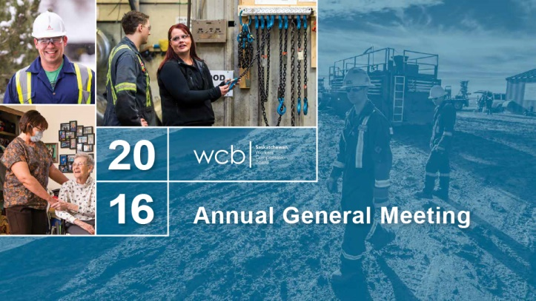

Gord Dobrowolsky
Good morning, Ladies and Gentlemen.
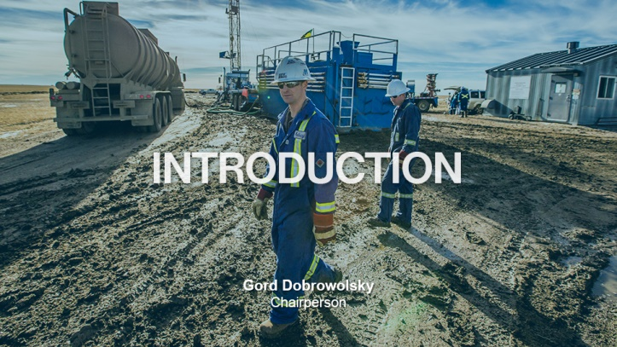

Welcome, everybody. We are looking forward to present but more appropriately to get your feedback after we do our presentations. Thank you for being here and again for your interest in the Saskatchewan Workers’ Compensation Board. I am joined by my two colleagues on the Board, Larry Flowers, and Garry Hamblin. It is indeed my pleasure to be the Chair of the WCB in Saskatchewan. Our CEO, Peter Federko, will be up in a few minutes to introduce the VPs with regards to their presentations. But today we are indeed pleased to share with you the results of the 2016 year at the WCB. As stewards of the Workers’ Compensation system in Saskatchewan it is our goal and vision at the WCB to provide excellent service to our customers, the workers, and employers of Saskatchewan.

It is our responsibility to provide excellent service while being cost effective and efficient with employers’ funds. It is also our mandate to assist Saskatchewan employers and workers in their injury prevention efforts to meet our goal of Mission Zero which of course stands for zero injuries, zero fatalities, and zero suffering. Another part of our responsibility is to communicate with you, our customers. And today, Ladies and Gentlemen, is our 18th public meeting in 2017 in the province. We are doing our best to get out there and communicate with you. As an example, this year over 1,000 people participated in 16 industry specific rate model sessions held in February and March. And over 500 people attended our 20th compensation institute also in March. As representatives of your compensation system we have an obligation to create opportunities like this to meet with you to share information and to answer your questions.
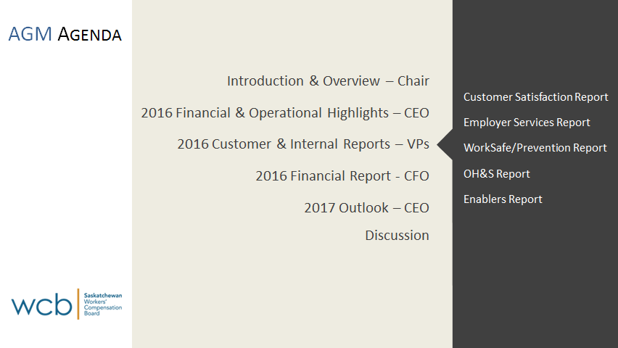

Our agenda today is meant to give you a high level overview of our 2016 results. For those looking for more in depth information with regards to questions or comments you have, we are available after, one-on-one, and it’s also available in our annual report and on our website. We will have some time for you to ask questions at the end of the session. In just a few minutes as I mentioned before Peter will introduce our Chief Financial Officer and our VPs will come to share their financial and operational highlights with you. But first I would like to briefly review the principles that govern our compensation system, the Meredith Principles.
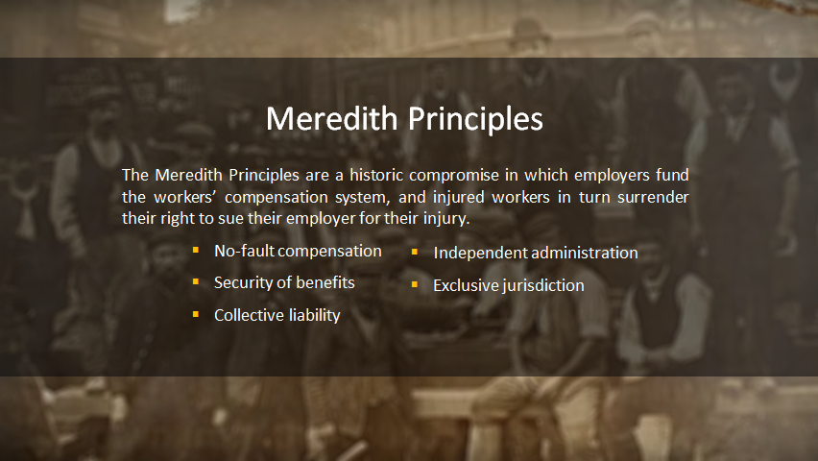

The Saskatchewan WCB began operations in 1930. We have exclusive jurisdiction in Saskatchewan and we are an independent board fully funded by employer premiums and investment income. We are legislated under The Saskatchewan Workers’ Compensation Act, 2013, to protect employers from lawsuits and deliver benefits to workers. The foundation of the Canadian compensation system is built on five basic principles, the Meredith Principles. These principles were adopted over 100 years ago and they are still as valid and important today as they ever were. The Meredith Principles and our system are built on the Historic Compromise that provides for an employer-funded compensation system in exchange for which workers give up their right to sue. The following four-minute video gives an excellent history of the compensation system in Canada.

That video speaks volumes to me, personally, because I was not always in a suit and tie, very much a labourer as a Ukrainian farm boy from Rural Saskatchewan and I still have the scars to prove it. Anyway, I hope you enjoyed that. It’s an excellent video.
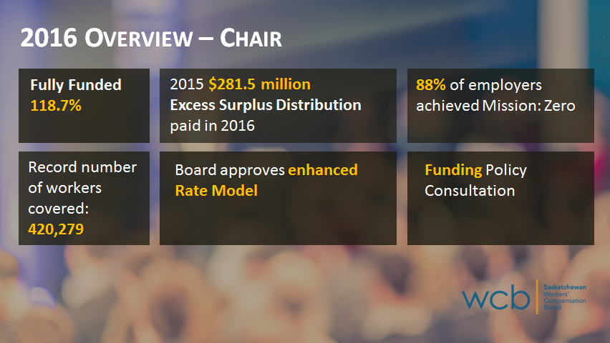

As you will hear today, in 2016 our operational results were positive for employers, injured workers and the public, and like any organization we are not without our challenges. We will share more about this later in the presentation. But I am pleased to report that at 118.7% we remain fully funded. We had excess surplus of 281.5 million in 2015 which we distributed in July and December of 2016. And in 2014 we also had another surplus of 141 million which we distributed in 2015. Very simple math, ladies and gentlemen: in 18 months this board has distributed 422.5 million excess surplus dollars to employers in Saskatchewan. Also we covered more workers than ever before in the history of the province, in excess of 420,000, a record number of workers while continuing to be safer at your workplace throughout the province. So if you get the picture, we had way more workers than ever before and safety was never higher than ever before, so a very, very good combination, for sure. In 2016, 88% of employers achieved Mission Zero, and this has been climbing over the last few years because the previous year it was 87%. So congratulations to you employers who achieved that. This means 88% of the 47,000 registered employers did not report any workplace injuries. This is a huge success and a testament to the safety work being done in our province.

Following an actuarial review the board approved recommendations to enhance our rate model. In 2018 we will transition fully to the new model. The board asked customers for feedback on how to handle the impact of moving to the new model and after considering the feedback received the board approved full implementation beginning in 2018, and many of you were at the educational sessions and also the consultation sessions. Employers who will see their rates go down as a result of the new model will receive full benefit in 2018. However, to mitigate the impact on employers and those rate codes where premiums are going up the board has approved appropriation from the injury fund to cover the incremental costs of moving to the new model for the 2018 premium year. Subsequent to 2018 employer premiums will be based on their claims experience as determined under the new model. The board has also just approved changes to the funding policy. We have been busy. Peter will speak more about this in our outlook section of the presentation.

As I mentioned before, while we are not without our challenges like any business, much of the success you will hear today is a credit to our Saskatchewan workers and employers and to the fabulous WCB staff who work together to make our system without a doubt one of the best in Canada. Ladies and Gentlemen, I will now turn it over to Peter for a more in depth view of what we are doing.

Peter Federko
Thank you, Gord. First I would like to join with Gord in welcoming you all here toda. I am joined today by our Vice Presidents: Mick Williams, the Vice President of Administration and Acting Vice President of Operations; Phil Germain, who is our Vice President of Prevention and Employer Services; Ann Schultz, who is our Chief Financial Officer; and the newbie to our executive team, Stuart Cunningham, who is our Vice President of Human Resources and Communications. Each of them will follow me and give more in depth presentations about our financial and operational results for 2016, and of course we are all available here.
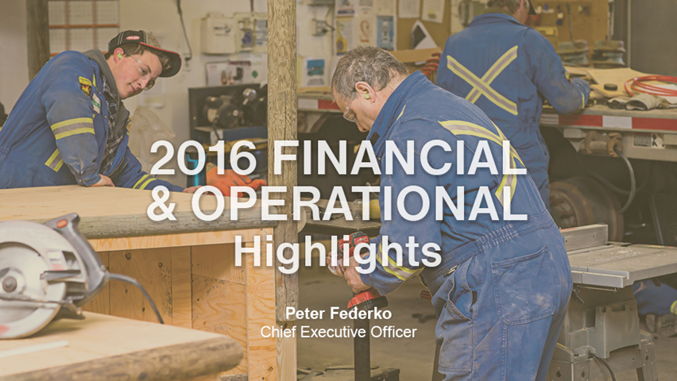

A general, high level overview of how we actually proceed with deciding what we are going to do in any given year. On an annual basis the executive engages with our board members to actually review the strategic direction for our organization to set the direction for us. I am very, very pleased that there has been stability in terms of the direction that we as an organization have been going and the vision that we have been pursuing. For several consecutive years now we are in constant pursuit of excellence as it relates to delivery of customer service for both our workers and our employers. And as dictated I guess by the vision of our organization, as confirmed by our board, we want to excel at the development and delivery of compensation and prevention programs and services.

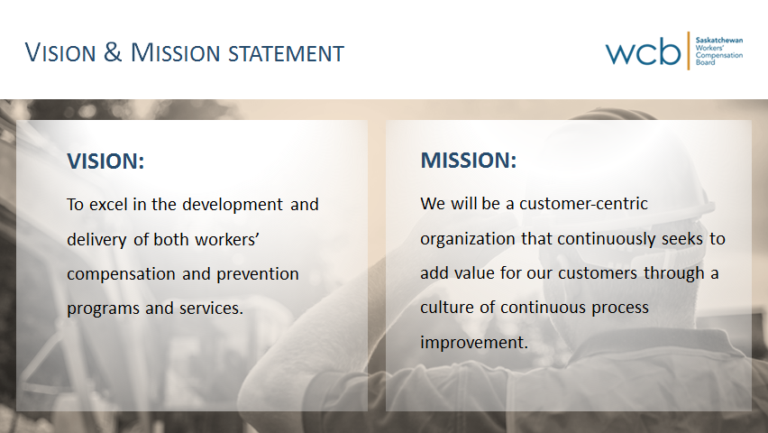

The board further provides us direction through the Mission Statement in terms of how we act to proceed in the pursuit of excellence in customer service. And in 2015 the board gave us a new Mission Statement to really focus our efforts on how we become an excellent insurance company delivering excellent service to our customers. The board called on us to become a customer-centred organization, putting the customer at the centre of what we do by continuously seeking to add value for our customers through a culture of continuous process improvement -- and I will talk a little bit more about as we call it CPI or Continuous Process Improvement. So daily looking for opportunities to improve the services that we provide to the customers of our province. This is really our starting point as an administration that sets us now into motion in terms of developing our plans for the coming year. To translate that of course the board also provides oversight with respect to how we the executive are performing in fulfilling or pursuing the vision of our organization. And we use a balanced scorecard for purposes of reporting the degree to which we are approaching excellence in service.

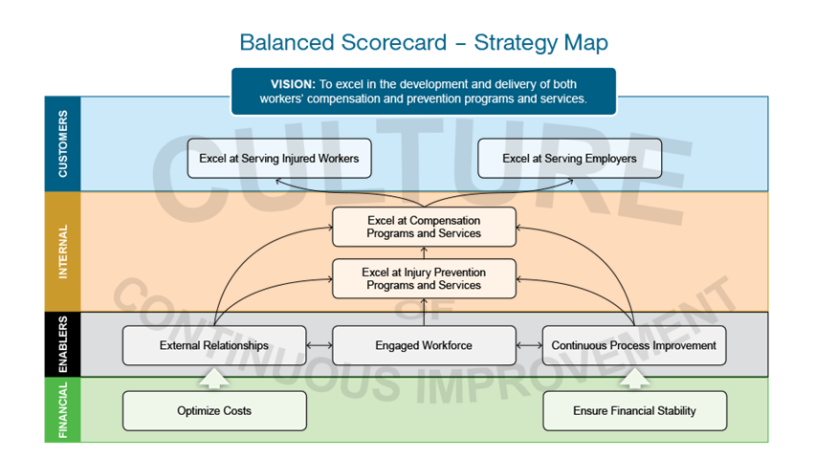

So this, up on the screen here, is what we call our Balanced Scorecard Strategy Map, and it’s simply a translation of the strategic plan and our strategic objectives as it relates to the pursuit of customer service.

We start with our Vision Statement requiring us to be excellent at serving our customers, and then we drill it down into what we call four perspectives. The first one is customer perspective, and our ultimate goal is the pursuit of excellence, the achievement of excellent service to our customers -- and we have indicators and measures that we report to the board on a monthly and quarterly basis relative to how we are doing on that. Mick is going to get into the further details about the indicators that we use and how we are doing with respect to our challenges in improving service to our customers.

The next perspective is what we call our internal perspective, and those are really indicators about how well we are doing in running our program, so it seeks to drill down into how effective our compensation and injury prevention programs are.

Then we get into the enablers section which is really how we go about doing these kinds of things. One of the things that we have been abundantly aware is there is very little that we can do on our own. We are solely dependent on the engagement that we have with both our staff but as well as our customers. Because without those relationships and cooperation and engagement of our customers and our staff we would be hard pressed with respect to the pursuit of excellence in customer service. So we have three objectives within that particular perspective. The first has to do with our external relationships, cultivating and maintaining relationships with our customers, understanding what customer expectations are and the opportunities for improvement and the challenges that our customers might be facing, and engaging our customers in partnerships to advance compensation and injury prevention programs. And both Mick and Phil will talk more about that as they get into the detail. We also need to have an engaged workforce and I will speak a little bit more about that and then Stuart for sure is going to drill down in it.

The next objective has to do with our CPI, our Continuous Process Improvement, which is really the foundational piece around how we go about achieving excellence in service as dictated by the Mission Statement that the board has provided to us. I will talk a little bit more about that in a minute. The last perspective is our financial perspective and that speaks to really two things: ensuring that we are always adequately funded so that security of benefits as dictated by Meredith Principles are never in question, so we are well funded at all times and we are optimizing our costs, we are operating efficiently as it relates to our administration costs, the cost of running the system, relative to the costs of the programs that we actually employ. On a monthly and quarterly basis -- and I will get into a little bit more detail when I deal with the operational plan at the backend of our presentation here in terms of the navigational indicators -- we would call these the evaluative indicators, these are the high level indicators that the board would monitor on an ongoing basis to determine how effective we are in pursuing the ultimate vision of our organization. As I said, one of the foundational pieces within the enablers section and as dictated by the Mission Statement that the board has provided to us is this concept of continuous process improvement.

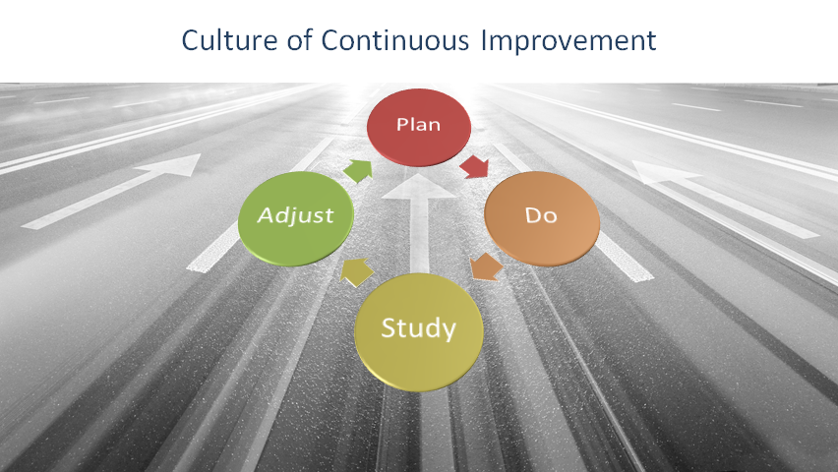

Continuous process improvement is 100% dependent on the level of engagement that we have with our staff. Our staff are the ones who know the work that they do in serving our customers and our staff are the ones that ought to be aware of the improvement opportunities that lay before them as it relates to ineffective or inefficient processes that we in management have provided over the years. We seek to engage our staff by having daily meetings, huddles, short little 15-minute meetings to talk about the work that went on yesterday and some of the challenges that actually might present us today in the work that we do.

In those huddles we also seek to engage staff in identification of problems or opportunities for improvement. And once we identify or engage our staff in identifying what opportunities there might be to improve our processes as it relates to serving our customers we then need to try and experiment, we need to try a solution. We apply root cause analysis to try and understand what the true root cause of the particular defect is and then apply what we call a countermeasure or a solution to that particular problem. But of course we are just kind of guessing. I mean we do our analysis but we are just kind of guessing as to what the actual solution might be. And so we engage in these experiments, we call them. We will run a change in a process for a few weeks. As we start that experiment we lay out what our expectations are with respect to what we hope that countermeasure is going to achieve in terms of a better outcome or an improved process and then we engage in what we call PDSA. And those of you who have studied management for years might recognize this as a very age-old Deming approach to planning and serving and improving quality. And it’s called Plan, Do, Study, Adjust, or PDSA as we call it. So once we identify a root cause and a potential countermeasure we plan on what we might actually do and then we actually do it. So we will run the experiment for a period of time. But after that defined period of time, whether it’s two weeks or a month where we try that particular countermeasure or solution we then study the outcomes. Did it achieve, did that particular countermeasure achieve what we hoped it would achieve? And if it didn’t, then we adjust that and we try something else or something in addition to. If it did work we then consider implementing it as a new standardized process that would be more effective in providing greater value to our customers.

Fundamental to our ability to better serving our customers is the engagement of the staff, and it’s through this methodology of continuous process improvement, daily looking for opportunities to improve processes, that we engage our staff in our daily huddles in our experiments and in our Plan, Do, Study, Adjust, applying scientific thinking to truly understand what the root cause of the particular problem or opportunity is and apply a solution to that particular problem that our staff have identified. So these are their ideas, these are their solutions. And culturally the change I think has been hardest for management, because it no longer works for us to be the problem solvers. I have been taught my entire care, you know through university and through my entire management career, to be person who has the solutions, to manage by objectives. As we enter into a culture of continuous process improvement management no longer plays that role. Rather what management’s role is, is facilitator, developer of problem solvers among the frontline staff and we become the coaches and developers of those staff. And that’s hard for someone who has worked as many years I have, wanting to give someone the answer as opposed to teaching them how to discover the answer and try and find the solution themselves. That’s been a huge cultural shift for us and I think Mick and perhaps Stuart are going to talk a little bit more about that.

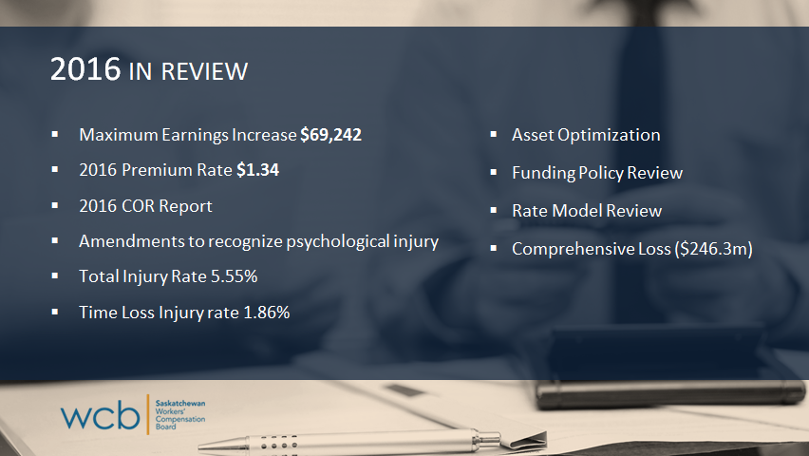

2016, as Gord alluded to, has been a fairly busy year for us. In addition to introducing continuous process improvement a couple years ago now and the challenges that presents in terms of how that changes the way we do our work, many other things were going on in 2016. Those of you that have been coming to this for a while or are familiar with our compensation system know that in 2014 government introduced new legislation and one of the pieces of that new legislation was changing the maximum insurable wage or the maximum compensable wage. So prior to 2014 our maximum was hardwired in the legislation at $55,000. The new legislation introduced an increase in that maximum. Starting in 2014 it went from 55 to 59, and then from 59 to 65 maybe, and then 65 to 69,000 in 2016. So the legislation also requires that by 2019 our maximum compensable and insurable wage will equal 165% of average weekly wage. Today we estimate that just to be a little shy of $90,000. We are on our way to increasing that maximum. The maximum, as I said, in 2016 was $69,000. That’s increasing to about $76,000 I believe for 2017.

As Gord alluded to, we were able to drop our premium rate in 2016 down to $1.34, nine consecutive years of a premium decrease. There was a Committee of Review report that was issued in 2016. There were 11 recommendations, four of which required legislative change. In November of 2016 the government introduced a new bill and a new regulation around psychological injuries, applying a rebuttable presumption clause to psychological injuries. Many other jurisdictions introduced this legislation before us; however, they limited the legislation to posttraumatic stress disorder or PTSD only for first responders. Our government went a step further. Psychological injury legislation does not limit this to PTSD, it’s any psychological injury, and it applies to all workers in our province. It is a rebuttable presumption, so for us that meant we needed to look at revisions to our policies and procedures about how we now go about confirming. So we start off with a premise that this is a work related psychological injury, requires a diagnosis by a psychiatrist or psychologist following a DSM-5 process, and once we have that diagnosis we are starting with the presumption that it is work related and our job becomes confirming that in fact work contributed predominantly to the cause of that psychological injury as opposed to other factors. That policy has been amended and recently approved by our board. It is up on our website if you would like to have a look at it.

As Gord indicated, fewer injuries again in 2016. We have seen both our total injury rate and our time loss injury rate drop, and we have been on a continuous decline since 2002, and I think Phil is going to get into greater detail around that. We also embarked upon an asset optimization strategy. We engaged in a funding policy review and we also undertook a review of our rate making model in 2016. I will talk a little bit more about those when I get to the Outlook, what our challenges and opportunities are, as we move forward. As Gord indicated, the board has made a decision to implement the new rate model effective 2018 and put in a transition plan to mitigate the impacts to employers who would see their premium rate go up as a result of the implementation of the new rate making model.

As Gord indicated, we are 118.7% funded, although we did report a comprehensive loss in 2016 of 246 million dollars. Again that loss is after the payment of 281.5 million dollars in surplus distribution, so had we not distributed that money we actually would have had a net income of 35 million dollars. We still remain strongly funded and seek to find opportunities to strengthen the financial stability of our organization, the accountability and transparency of the processes and programs that we use in delivering service to our customers.

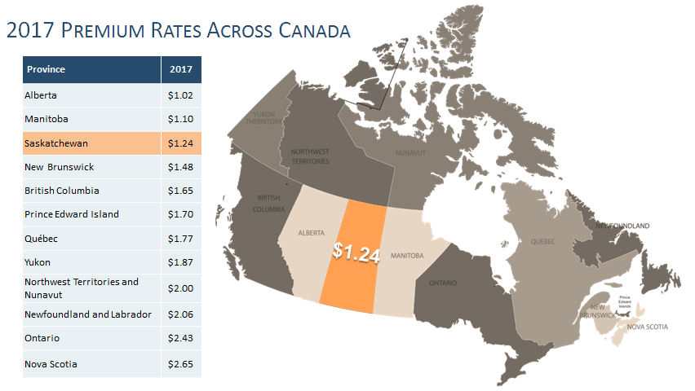

In addition to the decrease in the premium rate for 2016 you should all probably be aware that we also announced a decrease in the 2017 premium rate, the tenth consecutive year that we have dropped the premium rate. We are down to $1.24 now, representing the third-lowest premium rate in the country after Alberta and Manitoba. With that I will turn it over to Mick Williams to share some further details about our operational results and I will come back at the tail end to talk to you about what our outlook is for the coming years.

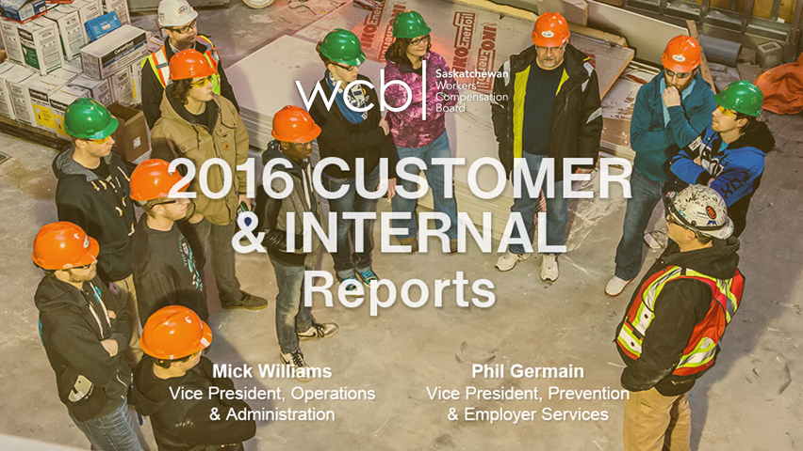

Mick Williams
Welcome to everyone as well. Thank you for joining us this morning. Peter and Gord have both talked about some of the positive things that happened, and while there were some positive things that happened in claims I think that you would have to call our 2016 year in claims to be mostly challenging in that we had trouble getting and reaching the objectives that we wanted to and we tried some things that didn’t work and I think we learned some things from that. But as Peter said, the real success for us would actually be meeting our customer satisfaction targets, because while things in claims that are important to us are things like durations being in good shape and the numbers of time loss claims always being reducing, at the end of the day it’s your satisfaction with this system that really is paramount for us, and that’s really kind of front and centre for us. This Committee of Review suggested that perhaps we are not using the right tool to measure this customer satisfaction, and so we have been doing some problem solving around that or some brainstorming. And it may be that the tool we have isn’t working, but I think to give it a fair test we have never hit the target that we have set on this tool so we are thinking that the Committee of Review is probably expressing concern that this tool isn’t giving us the insights we need into what we need to do to create more satisfaction with our program. And that may be the case, but I think we have a few more things we can do before we swap the tool out and that will give us a better indicator as to whether it’s the tool that’s the problem or of the methods that we are using.

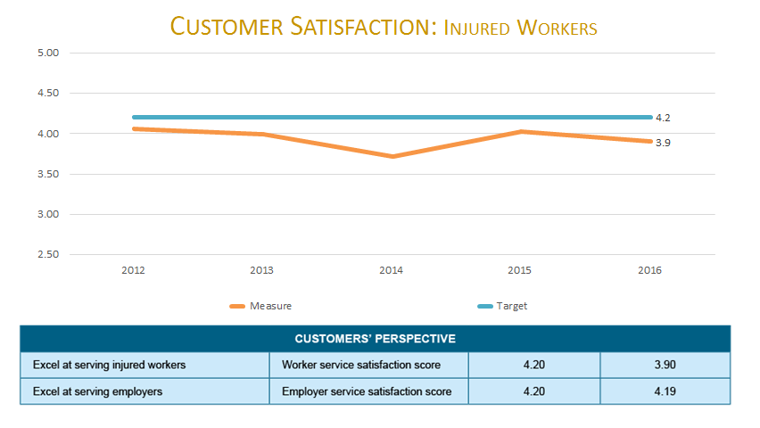

Our customer satisfaction for workers on this slide, as you will see in 2016 we experienced a drop. We did some things on the staffing side a little sooner than we probably should have, we made some decisions to not fund some positions, and I think we put our staff in a position where they had trouble getting to our customers and that I believe created the result that we have. Because most of the feedback in the survey is that once you get to our staff they are pretty good, they are knowledgeable, they are professional, but access to them is still an issue for us, so we need to do some things to figure out how to do that. We’ve got knowledgeable staff, we have got folks who are typically able to help you sort through and solve problems, but we haven’t set them up to be as available for you as they need to be. So that’s something that we have to sort through and figure out.

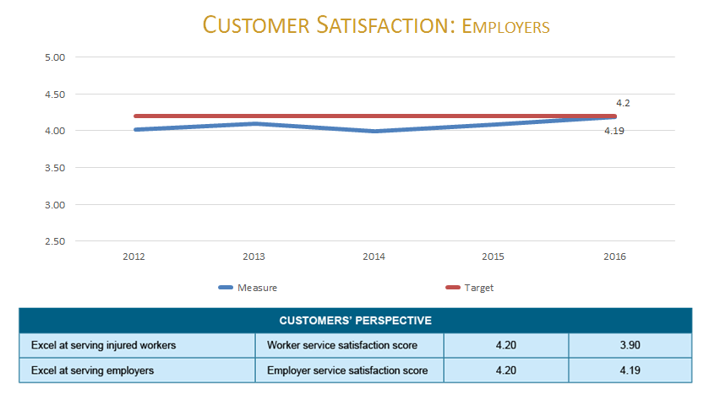

On the employer side the results were a little closer to target, but that might have had something to do with us sending a bunch of money out and that may have caused a bit of a blip or it may be that we are serving the employers better than the workers. So those are all things that we have to continue to try to figure out. At any rate the target up there is 4.2, but that’s a short-term target; the goal, just like Mission Zero, is -- 5 is where we want to be and once we hit 4.2 then we won’t stop there, we will need to get to the next level. The other thing that we were less successful than we would like to have been was on durations.

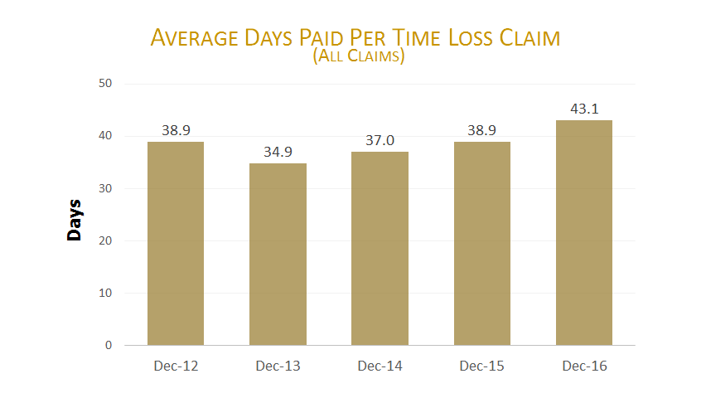

Throughout 2016 we experienced a big jump in durations. The good news about this is we have fewer time loss claims happening so the prevention efforts that you folks are undertaking seem to be helping in preventing these claims from being time loss and I think the return to work efforts and getting people accommodated more quickly are helping with that. What’s happening -- and probably a lot of these are related, but what’s happening is that the claims that we are getting are typically of a more severe nature or of a longer term nature and so our durations are going up. The folks in our Data Governance area have done some analysis on these durations and a lot of it is attributable to the claim mix but there is also a portion of this that was caused by us not being caught up in our work throughout the year. That’s going back to what I was talking about earlier, that’s where we think our opportunity is in being and staying caught up and also in looking for ways to kind of adjust our practices to the changing mix of claims. Some of the initiatives that we have undertaken -- and again the report out from the Committee of Review was very helpful for us in that it really highlighted a few areas that were both acute and chronically problems for us and kind of really highlighted some stuff and helped us get a little bit focussed on some of these areas.
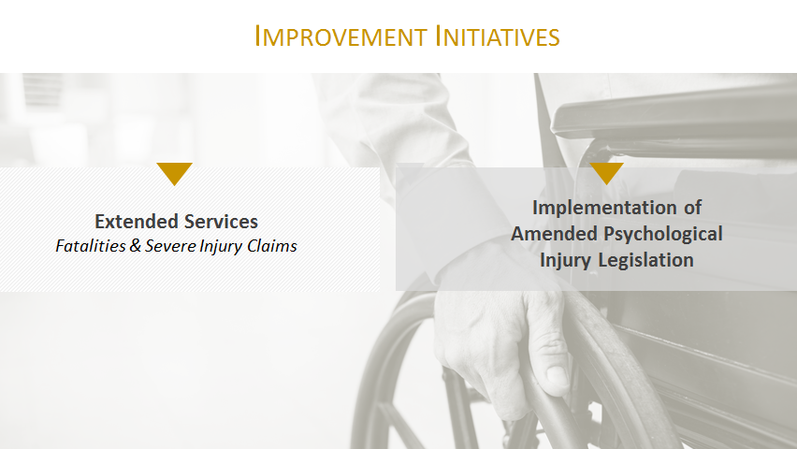

The first one I want to talk about is our extended services area where -- we have talked about at this meeting and at lots of meetings how we have had difficulty in our system getting our fatalities lower and preventing these fatalities from happening. We also had gotten, over the years we have had a fairly varied practice on how we attended to those types of injuries, and the feedback we got was that we needed to pay more attention to this and we are doing that. We are going to set up an area, or we are in the middle of setting up an area, where they specialize in fatalities and in injuries that are more severe.

That unit is up and we have got an individual who has been working in that area for a while, has figured some things out, and we are beginning to staff that area appropriately. So that’s one of the areas we have got some improvements. The implementation of the psychological injury legislation and this is one where we are in the midst of sorting through and figuring out how to do that. For the most part it -- we had this practice in place to a great extent already, but as Peter alluded to what was probably different than what we anticipated was the breadth of coverage of the legislation. The challenge for us in this particular area is to make sure that we are doing this in an effective way given the kind of, the newness of psychological injuries to our work. And given the breadth of the legislation, one of the challenges we have is to treat these workers in an effective way without transferring too much of the cost to the public health care system. What that’s caused us is we have got some challenges around having enough health care providers in place and having our adjudicators with the sort of experience and confidence with it so that we are experiencing some delays -- and if any of you have been working with this, we are slower than we want to be at getting these adjudicated and getting them moving along. So that’s another area where we have opportunities to make some improvements.

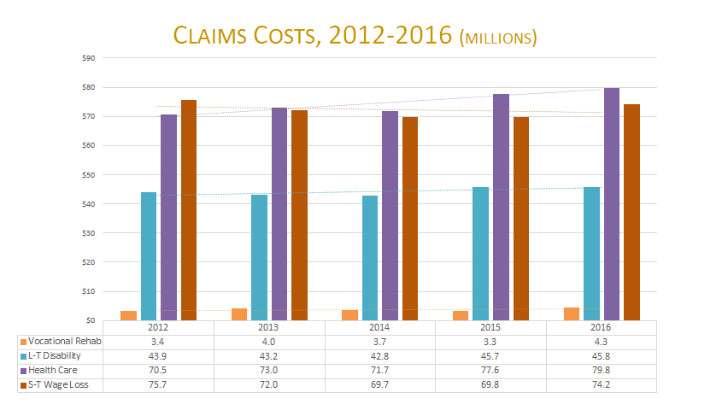

This slide shows our costs. I talked about durations going up earlier and that’s represented by the red bar on the far right-hand side in each of these years. You will see that our short-term wage loss has increased almost to the level that it was in 2012. We had made some gains over the past three years, but it crept back up on us. Again it’s almost entirely due to the durations going up. For the first time in three years we actually ended up paying more days of compensation and short-term compensation and we had that trend reversed --it snuck up on us, so the opportunity there to reverse that trend or to keep it from becoming a trend. Nothing else particularly jumps out other than we continue to have health care inflation which we have had some time, so that purple bar continues to be the one that climbs the fastest. This past year we also had some increases in our vocational rehabilitation costs. Some of that has to do with severity of injuries and sometimes just a little bit more difficulty in returning people to employment because the employment situations in the areas that they were working had tightened to some extent. That’s kind of the high level overview of 2016 from a claim perspective. What we know we need to do and what we are working on is we have got capable people working with us, we have got folks who we think are pretty good at helping both parties find their way through our system, but we need to do some things here to enable them to perhaps be more responsive, certainly be more responsive and perhaps be more flexible in our approach so that we can essentially drive those customer satisfaction numbers to where we want them to be.

Phillip Germain
Good morning, everyone. I’m happy to be here with you and provide you kind of a brief overview of what’s been happening on the premiums and injury prevention side of our business.

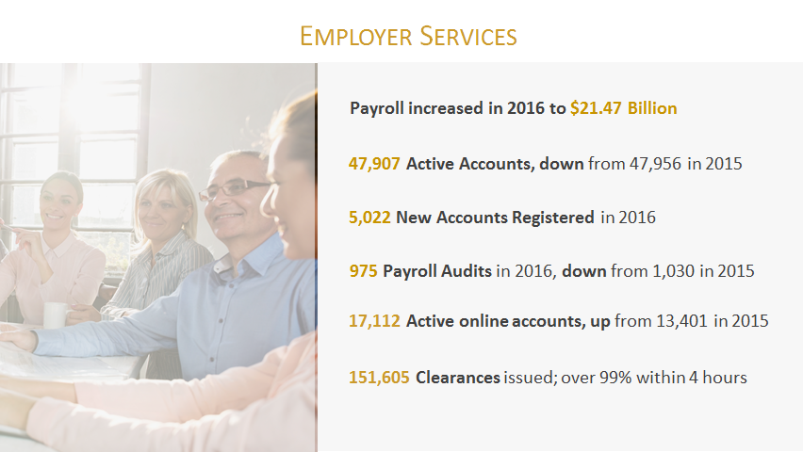

On the Employer Services side, for those that aren’t aware, we deal with basically the registration of employers, so we make sure employers are registered, classified into the right rate codes, really making sure that they are paying the right and fair premiums. We send out the bills, we collect the premiums. In situations where employers are working for each other we confirm the coverage so that if you are hiring a contractor you know that that employer has WCB coverage; those are called clearances. There is a lot of activity that happens in Employer Services to get employers registered, to confirm that registration, and to collect the premiums.

You can see a lot of the numbers here as it relates to Employer Services are increasing. For the first year in many, many years the number of total accounts that we have within WCB has levelled off. For example, the number of accounts registered with WCB have gone up from 45,000, to 46 to 47, to almost 48, and they levelled off at 47,900 from 2015 to 2016. But we still had 5,000 new employers register with us which means we had about 5,100 employers close their accounts. A lot of activity in 2016. The staff did a fabulous job of trying to keep on top of this. We obviously have some challenges and we are going to talk about some of that as it relates to the process improvement. One of the other things that Employer Services participates in is something called the assessment appeal process, there’s a couple of other departments that are involved. If an employer has an appeal related to their assessment or the premiums that they are paying they can send in an appeal. In 2016 we got 24 appeals out of the 47,000 accounts that occurred. Our goal is to deal with those appeals within 60 days. About 60% of those appeals were done within 60 days. The ones that went over 60 days it was just a matter of us taking time to get the right information from the employer, and once we got the right information the issue was settled usually within the 60 day period. I didn’t put that on the slide but it’s also another piece of the puzzle. We do help employers if they have got concerns about their premiums, try and sort through that, and if necessary through and appeal process.

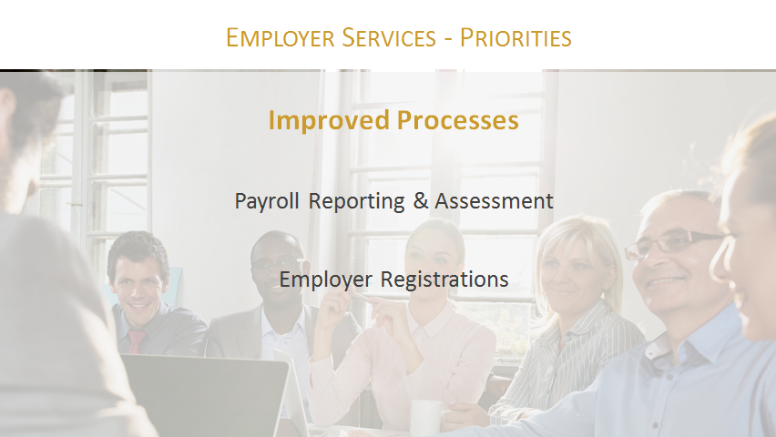

Like every other department within WCB we are looking at our processes and seeing how we can serve our customers better or add value in terms of the services that we are providing. Two of the key areas that we focussed on -- and actually I am going to talk about a third one -- but two of key areas: one was on our payroll reporting process. That’s important because sometimes we get into a back and forth and it causes employers extra time to get the right information in to us and/or it’s not convenient for them in terms of when they do business, they are not open from 8:00 to 4:47 like we are, they work sometimes 24 hours a day, seven days a week. We have worked a lot on trying to create online options for employers so that some of the things they can do around reporting their payroll, getting their assessments done, are available at their convenience. And we were able -- this has been about a two or a three-year project and every year we continue to add new features to those online processes.

In 2016 we made it easier for employers to search and assess contractors online, which if any of you deal with contractors as a part of your regular business you know that can be difficult and a timely process in getting all that information to WCB, so we have tried to streamline that, as well as account closures and maintenance related issues so that employers can more easily close their account and/or update information. We have got more projects coming through the pipeline to try and make that process even easier.

If I go back to 2014 our goal -- and I hate to say this, but our service level goal was to have 90% of employers registered within ten business days and the management team in that area recognized that that’s not good service. But even at that, we were achieving that goal only about 60% of the time, so we were only getting employers registered about 60% of the time within ten business days, so not good. And they set a goal of improving that. By the end of 2015 we had improved that to 85% of employers being registered within ten business days which caused us to set a new goal for 2016, to get 90% of employers registered within five business days. Now we have set a new goal so we don’t have anything to compare it to, but what I can tell you is in the first half of 2016 we were getting roughly 50% of employers registered within five business days. In the second half of 2016 that improved to about 65, 66%. We are making gains, we are not where we want to be. And the ultimate goal is not five business days for registrations. The ultimate goal in the next few years is to get to within a 24 hour service level, but we are kind of slowly marching towards that. The other thing I want to hit on is accessibility. A couple of years ago we had noted, because of better information through our phone system, we were actually abandoning about 25, 30% of calls, which means we didn’t get to it before the customer hung up or they left us a voice message. So the management and staff said, “That’s not good. We need to be more accessible.” And so we embarked on an initiative, to start trying to answer 100% of our calls. And we are at about 95%. So when you phone the first time we get to about 95% of calls when you call. The other thing that we have done -- and again I’m a little bit sad to say we might be the last business in Saskatchewan to now have our phone lines and our business open at noon hours. So for those businesses that used to try and contact us during the noon hour we were shut down, the phones, the doors, we were not available. Now we are open through the phones and regular business during noon hour. Those are subtle and small but meaningful service level improvements that we find, through feedback from you the customers, are actually improving the level of service.

On the prevention side, when we think about prevention we don’t think of it in just one number. I think most of you would know that the measure of success was based on the time loss injury rate. Well for the last four or five years now we don’t think of it in that term. We look at a number of numbers, time loss injury rate, total injury rate, number of claims, percentage of employers that are reaching Mission Zero, number of fatalities, and what we like to see is all of these numbers going in the right direction. And if we see that we believe it’s just an indication that our efforts to help improve health and safety within workplaces are working.
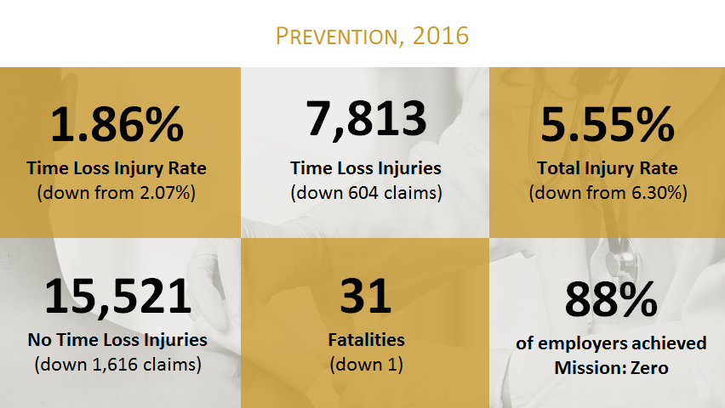

As you can see from these numbers the time loss injury rate went down from 2.07 to 1.86, time loss claims went down, total no time loss claims went down, fatalities went down by one but still high. And the number, percentage of employers that reach Mission Zero has actually crept up over the last few years from 85 to 86, to 87, and in 2016 reached 88%. So those numbers are all trending in the right direction.
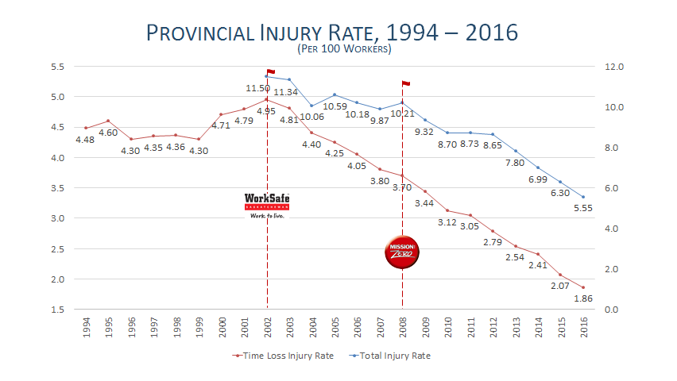

This is a snapshot over a bit longer period to show you the trends that are really happening in the injury rates in Saskatchewan, and you can see since the development of Mission Zero and WorkSafe there have been a lot of gains and momentum made in trying to create awareness around injury prevention that has ultimately resulted in employers and workers and other organizations really achieving a lot of success in driving down injuries and injury rates. Since 2002 when we started WorkSafe, which was the all-time highest time loss injury rate we had ever in Saskatchewan, we seen a 62% decrease since we started WorkSafe. Mission Zero was started in 2008 and it’s at that point we have started to see really successful trends around the total injury rate. We believe through our partners that we are starting to have a lot of success in raising the awareness around injury prevention and people really digging in and trying to figure out what they can do to prevent injuries within their workplace or help others prevent injuries within workplaces.

During this time -- and just to be clear, the reductions in the time loss and total injury rate are a combination of an increased net workforce and a reduction in injuries, so the workforce from 2002 to 2016 grew from about 306, 307,000 to over 420,000. During that same time claims dropped from over 35,000 down to 23,350. So it was a combination of a dramatic increase in the workforce and quite a dramatic decrease in claims and injuries, so positive on both sides of that.
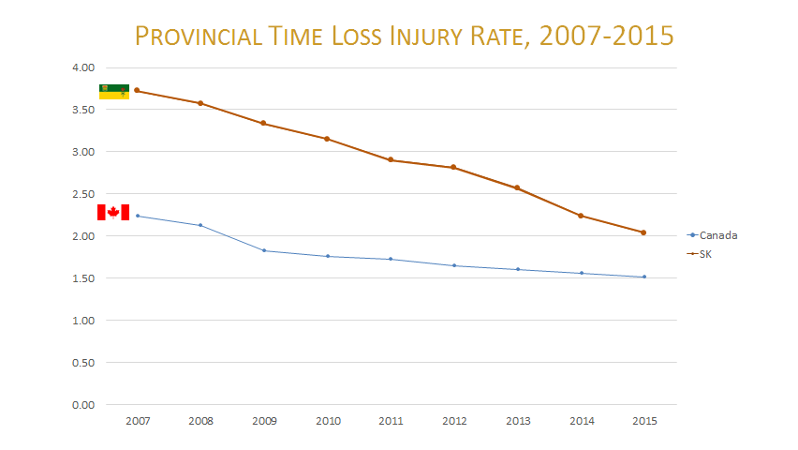

How do we fare when it comes to other jurisdictions? How do we compare to the national average? You can see we are still higher than the national average but we have made significant gains in trying to catch the national average and ultimately we want to be the best in Canada when it comes to injury prevention. Since 2007, our time loss injury rate has dropped over 45%. Nationally the average has been a drop of 32%, so all indications are -- while we don’t have all the data --we have gained even more in 2016 and we are gaining again it looks like even in 2017, so there has been a lot of progress made. This chart only goes to 2015, but the indications are that we made even more gains again in 2016.
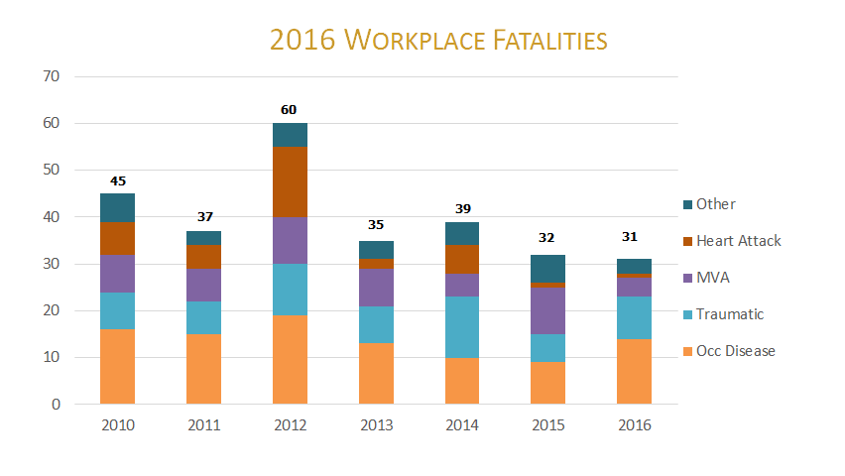

Through all the partnerships and all the efforts and all the things that we are doing we are slowing going from -- we were second-worst in the nation forever in terms of time loss injury rate. That improved to fourth-best in 2015 and it looks like we might be about third-best in 2016. But we are gaining and the point is, is that we are improving and that’s based on all the efforts of all of you and all the good things that are happening out there.

For those that have heard me speak before you will know that I, this one topic that used to be a real struggle and a concern, fatalities. While the fatality rate appears to be dropping ever so slightly it has not dropped 62%; it’s barely dropping over the same period of time, it’s dropping like 10-15% since 2002, negligible really compared to the injury rate. It’s really stuck, it’s quite flat, and you can see the number of fatalities are really not going down. As you see from the bottom bar, still there is a lot of asbestos-related fatalities. One of my concerns right now -- and we have put new asbestos-related materials on our website and we are trying to create awareness around the issue. The people that are dying today were exposed to asbestos in the ‘40s, ‘50s and ‘60s. All those buildings that they built are getting renovated right now and there are a new crop of workers that don’t even know what asbestos looks like, and I am afraid and concerned that we are created a pig in the python of asbestos claims that we might see in 20 or 30 years from now, so we are trying to create awareness around the importance. If you are renovating your home, do you even know what asbestos looks like? There are issues and concerns still around occupational disease that we need to address and even around asbestos despite the fact it’s banned in Canada.

Construction once again, unfortunately, had the most fatalities, at seven in 2016. There were 13 of the 14 related occ disease, 13 of those were asbestos-related. Two people died due to electrocution, two people died due to falls, two people were shot, and then there were people that were crushed by different equipment, objects, and materials. It’s one of these things that we, with our partners at WorkSafe and our other partners across the province, we are going to be putting a real emphasis on trying to drive down fatalities. For whatever reason the things that we have been doing just have not been working so we have got to figure out how to do something different.
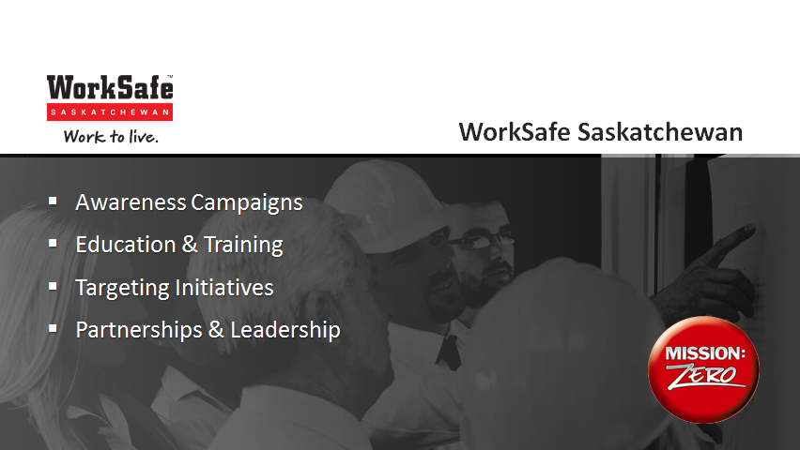

The provincial strategy around preventing injuries, and from our view how do we get there? We have had a provincial strategy with four basic pillars: raising awareness, providing education and training, targeting the industries’ occupations, things like that, issues. And as Peter talked about we would not be able to do any of this on our own, it would be impossible, and we do it through partnerships, formal and informal partnerships. I’m just going to touch on each of these real quickly.

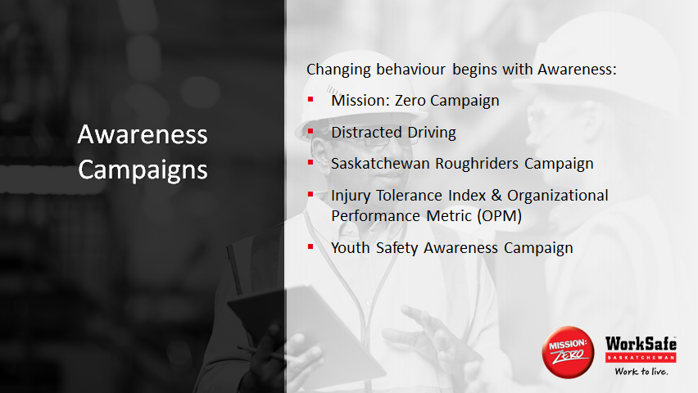

There’s examples of the different things we do. We have multilevel campaigns, we are out there very generically around promoting WorkSafe and Mission Zero, but we also have a number of targeted campaigns. After occupational disease and asbestos-related fatalities the number one leading fatality are motor vehicle related deaths, which is why we have a whole campaign around distracted driving. We help raise awareness through partners like the Saskatchewan Roughriders. We measure through our campaign the perceptions of people’s tolerance around prevention and injuries and we use that information to try and reach out in the right way to keep injury prevention moving forward. And of course the ultimate goal is, even though some of us might be lost causes, if we can get to the youth we can continually make this better as we go forward. So since 2008 a serious focus on reaching youth with different messages, education.

You can see through this as an example of ways that we reach out to youth and have conversations about raising awareness. There are other strategies and working through WorkSafe and the Ministry of Labour Relations and Workplace Safety we are reaching out to employers who hire lots of youth, making sure they have the right orientation, education and training. There is different pieces of the puzzle that we are working on to try and make sure that the youth understand the importance of these issues and that the next generation is going to get it even better than we are.

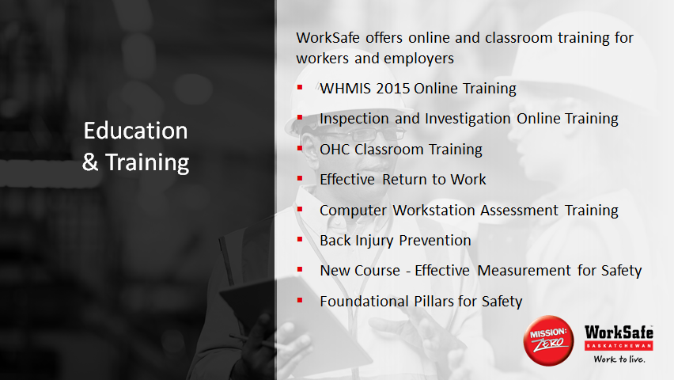

On the education and training side you can see from a WorkSafe perspective what we actually deliver through WorkSafe. In 2016 we trained over 7,000 employers and workers in various classroom and online courses and our partners, just the WorkSafe courses, trained another two or 3,000, and that doesn’t speak to the tens of thousands that they have trained in all their courses. Just on the WorkSafe courses that we offer, between us and our partners we are reaching nine or 10,000 workers and employers every year.

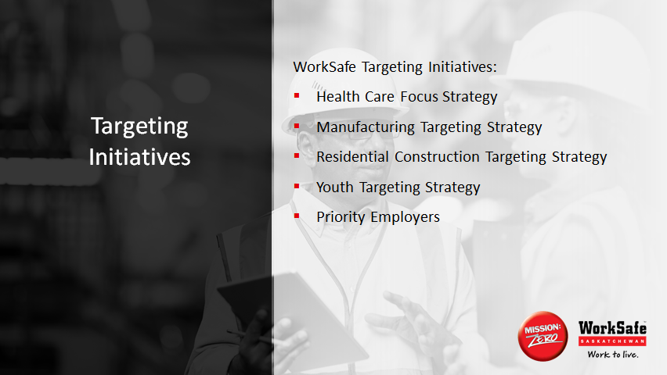

One of first initiatives we have ever done through WorkSafe was the whole targeting initiative. And like I said, we target industries, target occupations, demographics, and we target employers. These are the list of targeting initiatives we currently have on the go and we are developing more. All of these targeting initiatives are done through partnerships. The manufacturing targeting strategy was done in partnership with the Chiropractors Association and the Saskatchewan Manufacturers Safety Association, SASM.

The residential construction targeting strategy was done in partnership not between just WorkSafe, LRWS, WCB, but the Saskatchewan Construction Safety Association, the Residential Construction Association, and we partner together to create these three-prong strategies: creating awareness about some of the key issues, providing education and resources to actually start to deal with those issues, and our Prevention staff visit various workplaces that are struggling with some of these issues and really encourage them to get involved. We have seen success in every one of these strategies.

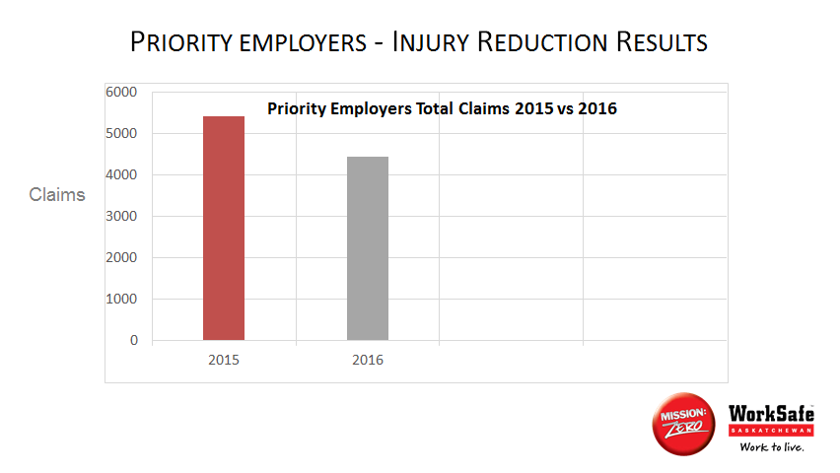

The strategy that we have been working on since 2002 was the priority employers strategy. Way back then we started with ten employers. Today we have 186 employers on that priority employer list, they represent about a half a percent of all the employers within our system and represent about 20 to 30% of all the claims in our system. Year-over-year over year we have great success with these priority strategies. We reach out to them really trying to develop, “How can we help you develop and implement a better way of preventing injuries?” Today we have a three-prong process. We work on compliance first, then we work with them making sure they have got a system to manage health and safety, and the last step is making sure they are aware of the cultural pieces that drive health and safety within the workplace.

Last year the priority employers, as you can see from this chart, collectively reduced their total injury rate by 16.53% and reduced their time loss injury rate by 17.53%. So another good year in terms of trying to help employers who may be struggling with this issue to move forward.

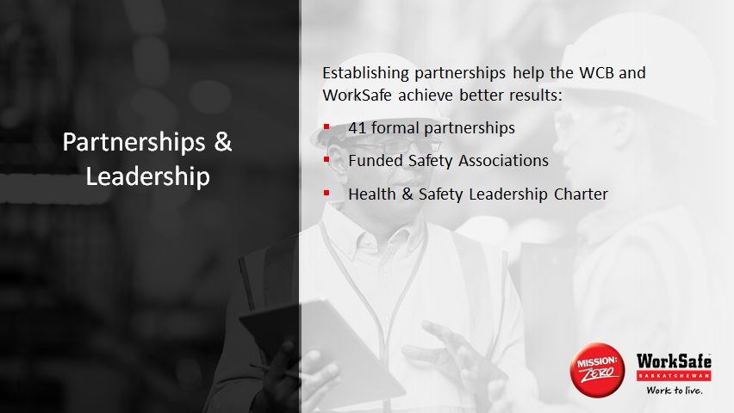

And last, but certainly not least, we would never do any of this without partnerships. We have over 41 formal partnerships in place that help drive WorkSafe, Mission: Zero, and injury prevention. From the Saskatchewan Brain Injury Association, to CNIB, to some of the Chambers -- in fact we just had a meeting with one of the Chambers yesterday to talk about what we can do around mental health in the workplace. We have many, many informal partnerships. A good friend of mine is here today who I have coached ringette with, she was out tirelessly last year promoting concussion prevention and brain injury prevention. And all of this is to try and raise awareness around the importance of injury prevention and what can we do to prevent it.
These partnerships are critical. Some of our longstanding partnerships are the funded safety associations where we work with industry to get agreement from a whole industry, a whole rate code, that they are prepared to add additional funding to their premium rates, we collect that funding and we hand it over to the safety association for the sole purpose that they help their industry identify and deal with injury prevention related issues.

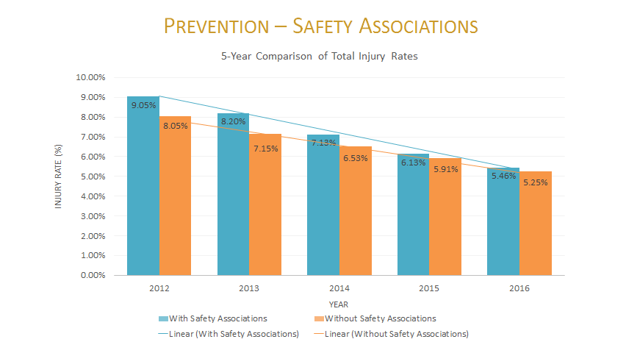

This slide illustrates the success of the safety association over time. And you have got to remember, so even though the safety associations are the blue lines and it’s like, “Wow, they have got a higher injury rate than industries without safety associations.” Yes, that’s true because we are talking about manufacturing, construction, health care, high risk industries. But what’s even more important about this chart is you can see the difference -- so if you go back to 2012 you can see the bars were quite far apart. The safety associations had higher injury rates than industries without safety associations. That gap has closed over time despite the fact they are dealing with very high risk related work like manufacturing, like construction, like health care. For us partnerships are critical, partnerships are really how a lot of this all gets done, and we are just here to try and help out. Speaking of partnerships I will now hand it over to Ray Anthony from the Ministry of Labour Relations and Workplace Safety. And LRWS is our partner on the WorkSafe side of things.

Ray Anthony
Good morning, everybody. On behalf of the Government of Saskatchewan, our Minister and Deputy Premier Don Morgan, and our Deputy Minister Mike Carr, I would like to thank you for this opportunity to bring you an update on the goings on at the Ministry of Labour Relations and Workplace Safety and particularly the Occupational Health and Safety division.

The function of the division is that of a regulator. We enforce Part III of The Saskatchewan Employment Act and the associated regulations that go along with that. I think the best way to think of it -- if you think in terms of employment standards as being the minimum level of employment in terms of holidays, pay and those sorts of things, Occupational Health and Safety legislation sets a minimum standard for health and safety among provincially regulated workplaces. We do advocate best practice and in fact many employers do go well beyond the regulations that we have in place, but we do enforce the minimum standard. We do this through two processes: one is through inspection and the other is through investigation and finally prosecution.
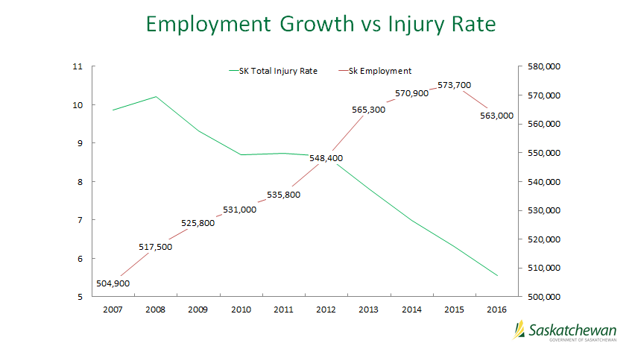

One of the challenges that’s been faced by both the board and by the government is that while we have been successful in having a declining rate, and in fact the fastest declining rate of injury in Canada, we have been doing so through a pretty good growth spurt. And for those of us that are involved in safety, growth spurts involve hiring of new workers, succession, and of course we have had quite an influx of immigrants. These are particularly vulnerable workers and they tend to have a much higher rate of accident as opposed to experienced, competent workers. So to obtain the level of reduction that we have in view of the influx of new workers, the influx of young workers, is quite a challenge. I guess we would say that it’s part and parcel of our job to educate as well as enforce. We are currently the jurisdiction is decreasing at the most rapid rate, which is good for us. We are chasing down the numbers that we have.

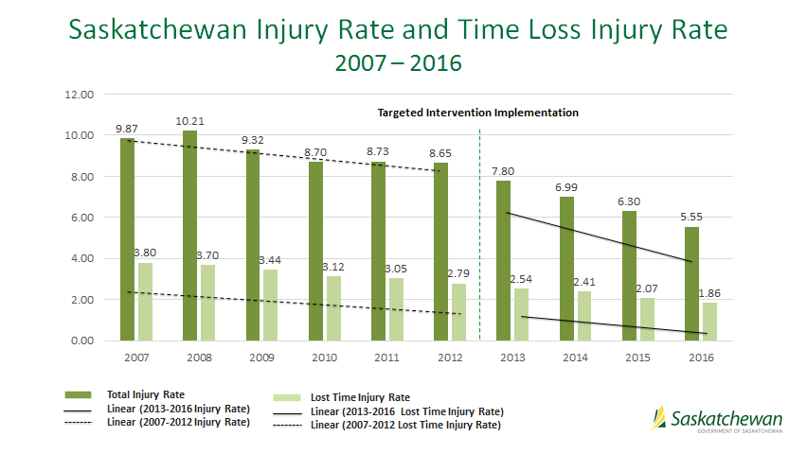
As you notice from this graph, in 2010 to 2012 we had quite a stall in our efforts to reduce the accident rate. And in 2013 we entered into a bit of an agreement with our WorkSafe partner, the Board and the priority employers and targeted employer strategies were put together. Viewing a five-year window, at that time 14% of employers were responsible for all the injuries and illness within the province. That actually means that 86% had achieved Mission Zero, looking at five-year window, which is not bad, but it doesn’t bode well for those 14%. So what we did was made a conscientious effort to target those employers that were injuring workers. And more along with that the targeting approach was focussed on those issues that were harming workers. So in other words they were not general inspections. Using the data that we received from the Board we targeted our work to those items that were hurting people, and that had a significant impact on the injury rate. As I said, we do two functions primarily. We inspect workplaces and these are the results of our inspections for an eleven-month period of 2016 and from April 1st to March 1st of 2017.

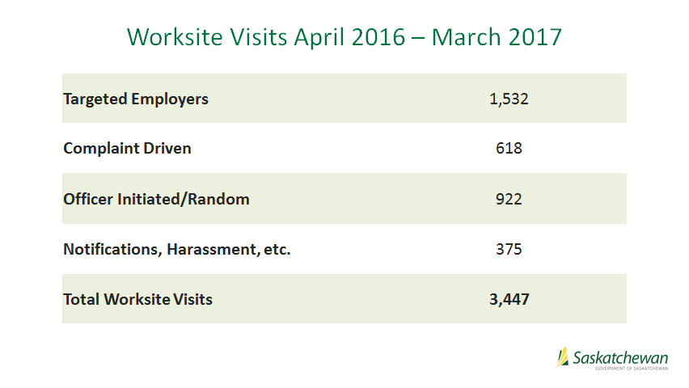

Basically random inspections accounted for 27% -- so we still do ad hoc random inspections, we could show up at any workplace in the province at any time -- but 29% were also reactive. That means that we actually got a call, got a complaint, got a notification, something happened that caused us to be invited to a workplace. 71% were proactive, which means that they were either targeted or brought about by investigation through an officer. Worksite visits have now increased to 3,447 for the 2016-17 year and actually adding the final month it increased to 3,882 inspections. The other thing we do is on the enforcement side. As I like to say, our worksite visits either wind up as compliance, appeal or prosecution, one of the three. And so we have two methodologies of enforcement.
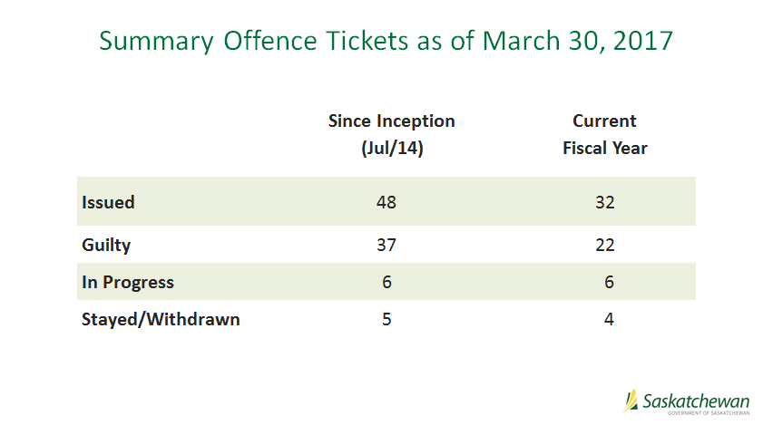

We use summary offence tickets for what we refer to as flagrant disregard. Those are cases where an employer flat out refuses to comply or is a repeat offender. And as Phil pointed out, seven of the traumatic fatalities were in the construction industry and almost all of the current 32 that were issued this fiscal year were issued on construction companies, so in other words as the severity of injury increases so does the severity of the method used and the penalty employed. We act as an investigation body much the same as any police service. We forward our files to the Ministry of Justice Crown Prosecutors Office. Those fatality and serious injury cases wind up in Provincial Court. The summary offence tickets wind up essentially in Traffic Court. This has been I guess you could call it an improvement in the speed of service. The Traffic Court ones are usually handled within 90 days whereas Provincial Court can go up to two, three, four years, depending on how long it takes to get a court date. Last year we had two occupational health officers that were designated as peace officers for the purpose of this enforcement. This year we will have six.
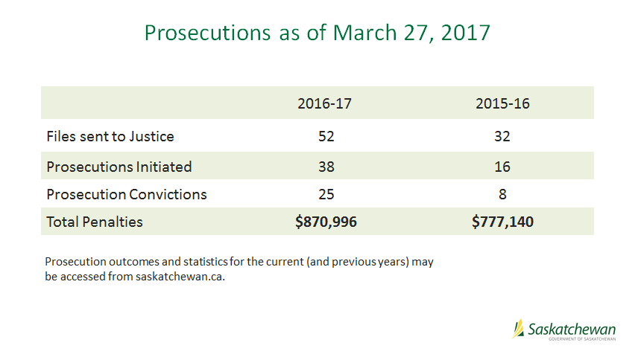

Finally, the major prosecutions: these are ones that result out of a serious injury or illness to a worker. As you can see it’s gone up quite a bit, 52 from 32. That’s an increase of 62% over the previous year. The fines are bit wonky. We only had a 12% increase but yet convictions have increased by almost 200%. Again I would say that I really don’t like having to do this. It’s a sign that someone has been injured, someone has been hurt an employer has suffered a loss. They are really not good things to do but they have to be done, and we remain committed to WorkSafe and we remain committed to Mission Zero. I am going to pass this off to Stuart Cunningham, VP of HR and Communications

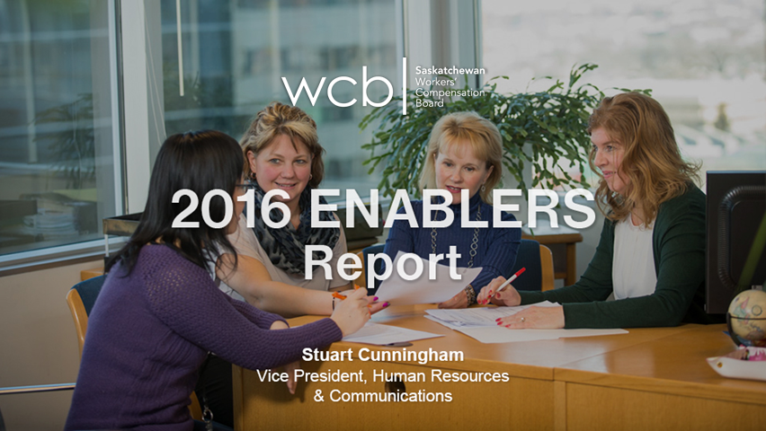

Stuart Cunningham
Good morning everybody and welcome again to everybody. I am here this morning to give you a short update on what we call our Enablers Report.

And really what that means is it’s one of those key elements that we believe that we are going to ensure that we are achieving customer satisfaction.

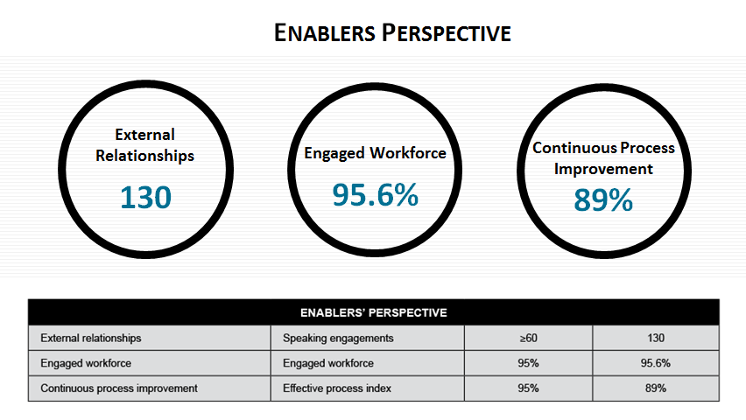

On the slide there you will see the first objective is around external relationships. And really what we are doing here is we are evaluating our performance as an organization with respect to the number of meaningful engagements that we have with our external customers, because at WCB we believe that building positive relationships and relations is an essential contributing factor to achieving that service satisfaction that I spoke of. Our measurement includes the number of presentations and speaking engagements that support the advancement of Mission Zero and the promotion of injury prevention through the WorkSafe brand. As you will note in the report that you have and on the slide we set a target for 2016 of greater than or equal to 60 engagements and we actually exceeded that score with a total of 130, most of which were realized on the prevention side.

In the middle our second enabling metric makes reference to our engaged workforce. In the most recent Committee of Review report it was noted that there was a need for WCB to be truly customer-centric. It really is this that motivates us as an organization to ensure that we are offering the most complete employee experience. We believe that happy, motivated, and engaged employees will derive better outcomes for all of our customers. For the purposes of the scorecard and the score that you see in front of you we do include other engagement indicators, for example the number of employee safety incidents that occur in addition to the results of our Employee Engagement survey, and it’s these components that give us the result of 95.6% for 2016 against our target of 95. And despite this number we do still have a whole lot of work to do to improve engagement, and I will get into that in more detail in the following slide.

The third element you will see is our performance around continuous process improvement. If you consider the comment that I just made about ensuring that we have a positive employee experience, we want to drive our staff towards becoming truly customer centric, and we believe that this progress is best indicated by how engaged our staff are in improving the processes that they work, and all of this should be in pursuit of adding value for the customer. As you can see, the target for the CPI index was 95% for 2016 and we achieved 89%. And so we track our success at this by looking at how we perform as an organization against a number of our key targets for improvement when it comes to process, and the 89% score that I mentioned is calculated on a weighted basis from five key processes that impact at the customer experience we believe the most. For example, those would be employer registrations within five days, our percentage of employer payroll assessment, our targeted employers’ injury rate, our claims payment accuracy, and the percentage of appeals completed within 30 days.

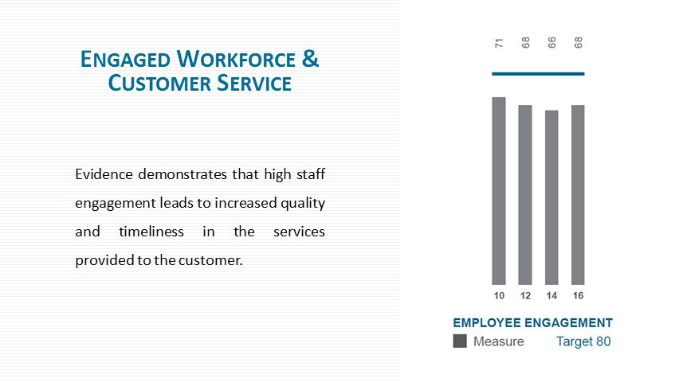

As I mentioned I did want to talk a little bit more about our employee engagement efforts in WCB. Every two years we administer a large survey to measure engagement amongst our staff. And as you can see on the slide we saw a slight uptick in our engagement scores in 2016 as compared to 2014. In addition during that two year period we run a quarterly poll survey to track our progress and this looks at a number of key questions that we believe are important to assess how we are doing from an engagement perspective. Generally speaking the results tend to be fairly positive with responses of about 76% favourable, in around the mid-seventies. However, consistently the two themes that arise from proven time and again as it relates to engagement are: number one, our practices in terms of management, leadership, communication with staff; and number two, regular and relevant feedback for employees in terms of how they are doing with their work.

Despite comparatively high levels of engagement in all of our key areas we do need to pay attention to what we can improve, and even though we do look at the results very closely it’s what we actually achieve to advance engagement that matters the most. To address these themes over the last year to two years we started daily management practices that have evolved over that time to include, as Peter mentioned, daily huddles with the team, daily or regular face-to-face coaching sessions between employees and their supervisor, and we have also initiated other methods that allow for rapid daily improvements to the work processes and the work flow. The staff seems to be generally enthusiastic about bringing ideas forward, seeing them put into action, and also understanding that the customer can actually enjoy a better experience from the idea that they brought forward. Even though there are some bumps in the road and learnings along the way we are hopeful that our persistence with this model of engagement, as well as continuing to try to improve, continue to do well in terms of what we already do well, we will see a rise in true engagement and an increase in value to our customers.

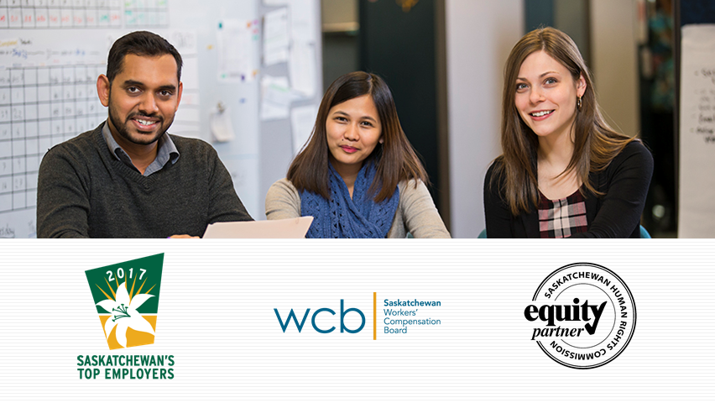

And finally I just want to mention a few things with respect to overall from an HR perspective. We are pleased to have been named as a Saskatchewan Top Employer again in 2016 and I am very pleased to share again this morning that we have also received this recognition for 2017, and actually WCB has achieved this milestone in five of the last six years. It’s fair to say that this recognition does truly help with our recruitment efforts in trying to attract and also retain the many and varied roles that go into an organization of this complexity. With respect to employee relations and the labour relations environment we have experienced relative stability throughout 2016, however our collective agreement did expire on December 31, 2016 and negotiations did only commence last month. Like many in the public sector WCB will play its part in containing public sector expenditure and so for me it becomes even more important to ensure that we find ways to continue to engage our staff during this period and ensure that we continue to strive for value being driven to our customer.

On that note I would like to take this opportunity again to recognize and appreciate the loyalty, dedication, commitment and contribution of our employees and the number of ideas and the quality of ideas and efforts that they have brought forward to improve work processes and provide that value that I spoke about. And that’s it for me and I just want to say thank you all for your time again this morning.

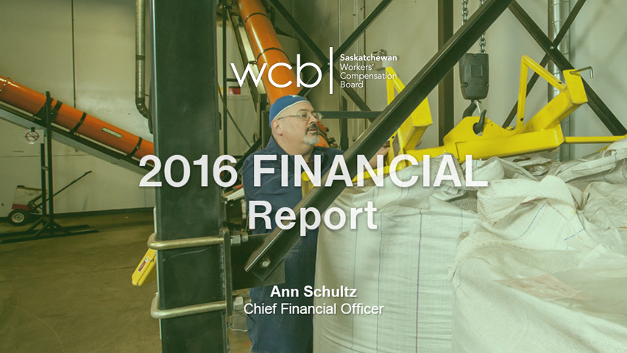

Ann Schultz
My name is Ann Schultz and I am the CFO at the WCB. I am going to be here to elaborate a bit more on the financial results that Gord and Peter have already alluded to.

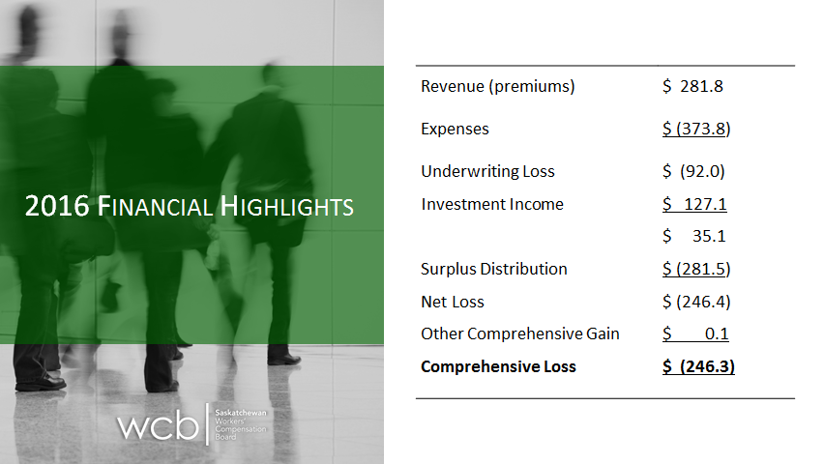

This slide is an overall look at our financial performance for the year. The Statement of Operations and Other Comprehensive Income starts with our premium revenue of 282 million to which expenses are applied. The expenses of 374 million include claims costs, administration, safety and prevention, and annuity interest. After we apply those expenses the resulting underwriting loss from insurance is 92 million dollars. Income from investments of 127 million is then recognized resulting in the 35.1 million dollars of net income before the surplus distribution. We did pay a surplus distribution in 2016 which related to the 2015 funded position and that’s recognized as an expense under the accounting rules. After a small $100,000 actuarial gain on WCB’s closed pension defined benefit plan the comprehensive loss for the year was 246.3 million dollars.

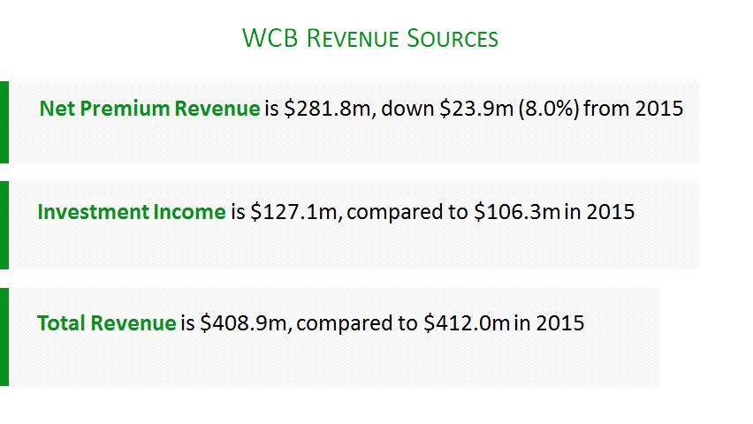

WCB has two sources of revenue, premiums and investment income. Premium revenue is driven by industry, payrolls and premium rates. In 2016 the average premium rate decreased from $1.46 to $1.34 and that was somewhat offset by the payroll growth. As a result our premium revenue declined from 2015 by almost 24 million dollars. Despite the difficult economic conditions for some sectors in the last year we did experience payroll growth in 2016. Accessible payrolls increased by about 2.3% to a provisional 21.5 billion from the 2015 actual of 20.99 billion, so about a half a billion dollar increase. Phil spoke to the increase in the number of registered employers and this has kind of levelled off in the last year. However, if you compare payroll in the last five years we have increased dramatically. The 2012 payroll was about 18 billion dollars, and this has increased as I said to the provisional 21.47 billion. However, approximately 2% of that 2.3 increase in the payroll in 2016 was attributable to the change in the legislation which increased maximum insurable earnings. About 2% was related to the increased max and about .3% to economic growth. The other thing that’s recognized in the premium revenue is the net cost of the experience rating program. In 2016 the net cost of the experience rating program, increased to 1.3 million dollars from $600,000 in 2015. Approximately 1,600 employers paid 25.6 million in surcharges while 23,600 employers received discounts of 26.9 million.

Investment income, the other major source of income, was 127.1 million dollars in 2016 compared to 106.3 million in 2015. Investment returns in 2016 were 7.1% compared to 5.6% in 2015. The investment income of 127 million includes 93 million dollars of realized investment income, so that’s regular interest, dividends and gains on this disposal of our investment assets. The balance that makes up the 127 million, 34.4 million, is the increase in unrealized value for the investments that we held at the end of the year. The following graph shows the relative proportion of WCB’s revenue sources for the last five years.

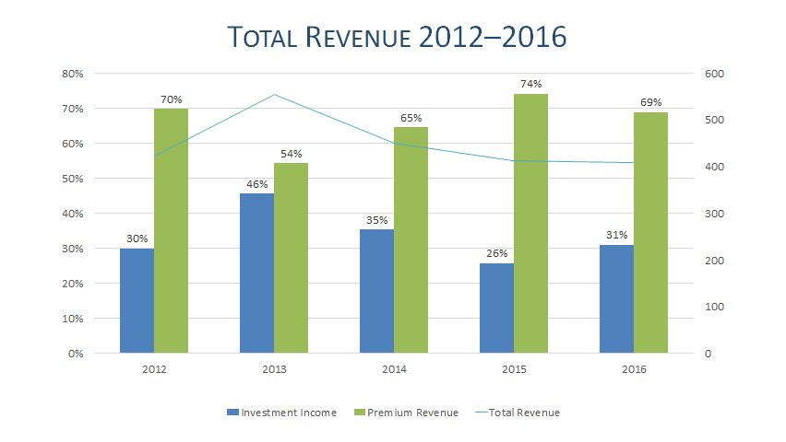

Investment income is the blue graph or the blue bars on the graph and premiums are green. With unrealized gains and losses being included in investment income there is a potential for significant fluctuation in investment income from year to year. The years from 2012 to 2016 have been relatively stable, but we do stand the chance that things will change as markets go up and down and our investment income will follow that trend. As an example -- it’s not on this graph, but 2011 was a very poor year investment wise and we actually had a negative return on our investments of 13%. This could compare to 2013 where we had 46% of our total revenue came from investment income. So there is lots of volatility.
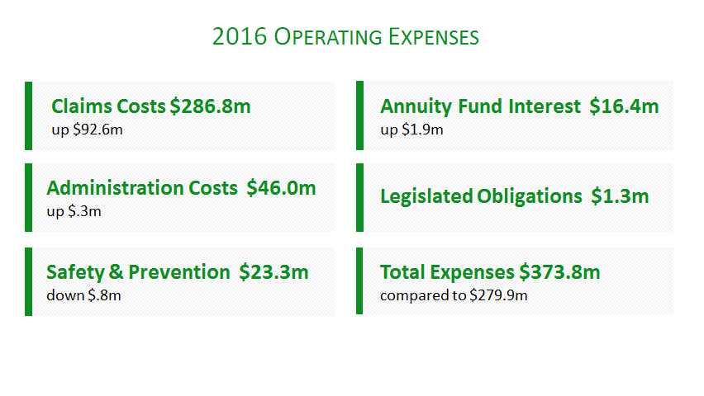

This slide is a review of our operating expenses for 2016 compared to 2015. Claims costs are up to 286.8 million. This is an increase of 92.6 million dollars. The 286.8 million includes the short-term and long-term compensation benefits including the impact of the increased maximum insurable earnings, health care costs, vocational rehab costs, and the actuarial adjustment to the benefit liability.

Administrative costs increased $300,000 from 2015 to 46 million dollars. Safety and prevention costs, which includes the OH&S program at the Ministry of Labour Relations and Workplace Safety, funds to safety associations, and WorkSafe Saskatchewan were down $800,000. Annuity interest was up 1.9 million dollars. Annuity interest is interest that we pay on funds that are set aside in a liability for the WCB for injured workers who are on compensation costs for 24 consecutive months, so we contribute 10% of their wage loss benefit to that fund and we pay interest on that fund. The purpose of the fund is to compensate injured workers for the fact that while they are receiving compensation benefits they are not able to contribute to Canada Pension Plan or a company pension plan and to provide them with a source of income upon retirement. The annuity fund interest is based on a five-year average of our investment returns and in 2016 the interest rate was 8.4%, and this compares to 7.6% that was paid in 2015 on those funds. Legislative obligations were 1.3 million dollars in 2016, the same amount as 2015, and these costs include the Office of the Workers’ Advocate and costs for the Committee of Review. Total expenses in 2016 were 374 million and that compares to about 280 million in 2015.

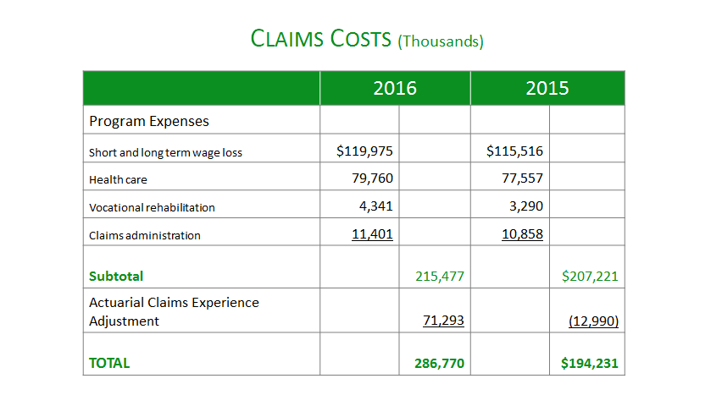

I wanted to review the claims costs in a little bit more detail. So Mick spoke to some of the reasons for the short-term costs going up related to the increase in durations, he spoke to health care inflation. The other large cost that was an exceptional thing this year was the adjustment to the actuarial claims experience.

The benefits liabilities on our balance sheet at the end of the year were 1.2 billion dollars. This is an increase of 71.3 million dollars from 2015. The reason for the increase is that when our actuary looked at our results for the year and did their projections they adjusted how they treat medical costs in that projection for future benefit costs, because they used to calculate the medical cost projections based on time loss counts, but what we have been seeing is that there is no longer a strong correlation between those costs and the number of time loss counts. So the actuary looked at our actual costs both on time loss and no time loss claims when they were doing their projection for medical costs. The other change was the fact that we are seeing increased durations. And on the slide that’s earlier in the presentation you can see that trend where durations are steadily increasing. The actuary said our claims are hanging around longer in the system, therefore they adjusted the way they calculate the future benefits for claims that are less than five years old that are in the system now. So these two changes were the main reason for the increase in the benefits liability in 2016.

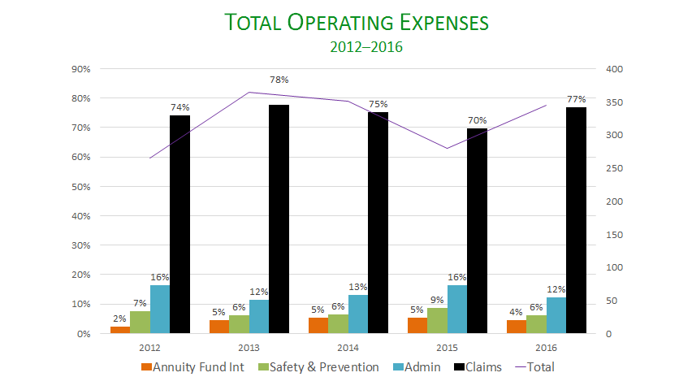

This graph shows the relative proportion of our various expense categories. As previously discussed, the actuarial adjustment to the benefit liability in 2016 included that 71.3 million dollar adjustment which increased the proportion of claims costs, represented by the black bar, to 77% in 2016. You will note that in 2013 and 2014 we also had blips, if you want to call it, in claims costs and those two also related to onetime events. In 2013 we increased the benefit liability to recognize the obligation for future claims costs related to the change in legislation with respect to maximum insurable earnings for claims that were in the system at that time. And in 2014 actuarial standards changed and we were required to recognize the liability for latent occupational disease. There was a lump sum adjustment of close to 80 million dollars in 2014. Without the actuarial adjustment in 2016 the proportion of administrative expenses to total expenses would have been approximately 15.2% rather than the 12% which is the result for 2016, and that’s more in line with other years when the claims costs and admin costs were on a more level basis. In 2015, the most recent year that data is available from the Association of Workers’ Compensation Boards of Canada, Saskatchewan had the fourth-lowest administrative costs per time loss claim in Canada. AWCBC also collects measurements from all the boards with respect to administration costs per $100 of assessable payroll and Saskatchewan was tied for the second-lowest administrative costs in 2015.

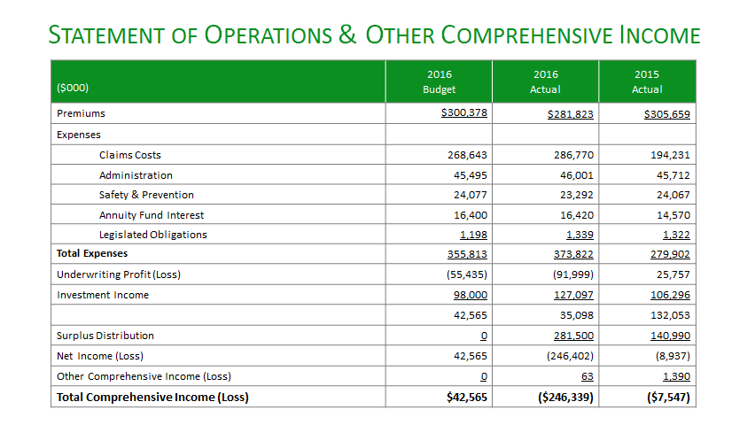

This slide has lots of detail and it compares our 2016 actual to our 2016 budget and 2015 actual results. I am going to focus on some of the budget variances for 2016. Premium revenue in 2016 was 20 million dollars under budget and this is due to the fact that the provisional payroll estimates for 2016 came in at around 21 billion dollars as compared to the 21.15 billion that we had anticipated. Claims costs were 18 million dollars over budget. The reason for this again is that benefit liability adjustment was 20.7 million more than we had anticipated while cash expenditures were actually 2.5 million dollars under what we had forecast mainly because of lower claim count numbers than we had anticipated when we set the budget for 2016. Administrative expenses are over budget by $500,000 in 2016 and this is mainly due to salaries being over budget. We charge fees to the Federal Government for managing their claims. If you look at our financial statements and the statement of administrative expenses. We are under budget there about 200,000 because we handled less claims for them. So their claim costs do not form part of the costs; we handle those claims, the Federal Government pays for the claims and we charge an administrative fee for doing that. The other thing that impacted our over budget situation is that the actuarially determined amount of our administrative expense that gets charged to the benefit liability was $500,000 less than we had anticipated. These items add up to about 1.4 million dollars and they contribute to the over budget and they are offset by underspent categories and the largest ones of those are amortization. We are about $400,000 less than we had planned and that’s due to the timing of the completion of some capital projects in 2016, and our computer services were also down about $500,000 due to lesser anticipated costs and again the timing of some of the work done in IT.

Safety and Prevention is under budget by $785,000. There is three things that contribute to that: WorkSafe was under budget by $200,000, and this was due to lower than anticipated production costs for some media campaigns; OH&S was also under budget by about $400,000; and the safety associations were also under budget by $150,000. Annuity fund interest was basically right on budget, and we were a bit over on legislated obligations by about 140,000, and that is mostly due to the Committee of Review costs in 2016. So our budgeted net income of 42.5 million compares to the actual results before the surplus distribution of 35.1 million in 2016.

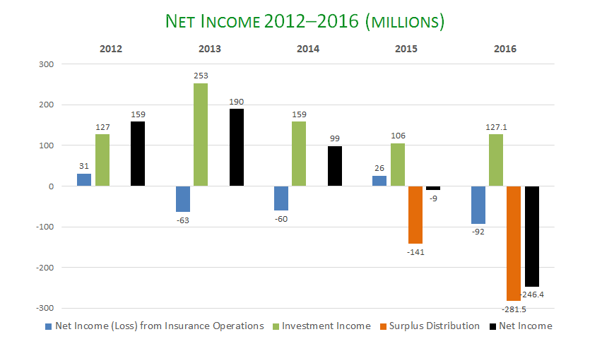

This slide is another look at our net income and it’s comparing the net income or loss from insurance operations to our investment income and also includes graphs, bars showing the surplus distribution, which are the orange bars, and our net income. The mix can change dramatically from year to year driven by changes in investment income and in the last couple years the impact of the surplus distribution also can be seen. So in 2016 the inclusion of that 281 million dollar surplus distribution resulted in our loss of 246 million.

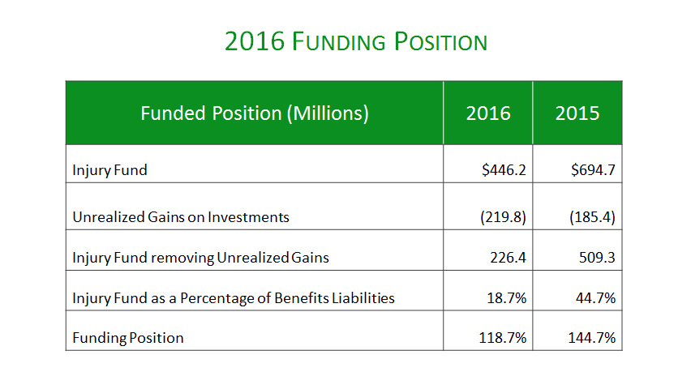

At the end of 2016 WCB’s funded position was 118.7%, as Peter previously announced, and this compares to the 144.7% position we were at at the end of 2015. The funding position in 2015 was before the approval and payout of the 281 million dollar surplus in 2016 and represents 24.7% of our funded position at that time. The targeted range for the injury fund according to policy is 5 to 20% of the benefits liability. In 2016 our benefits liability was 1.2 billion dollars. Investments per our financial statements are recorded at fair market value and the change in unrealized gains and losses is recorded through investment income. This means that investment income which can be volatile can produce large swings in operating surpluses and the injury fund. The WCB’s funding policy removes these unrealized gains and losses from the injury fund for the purpose of calculating the funding percentage. This promotes stability of the funding range year-over-year and takes out the fluctuation due to investment volatility.

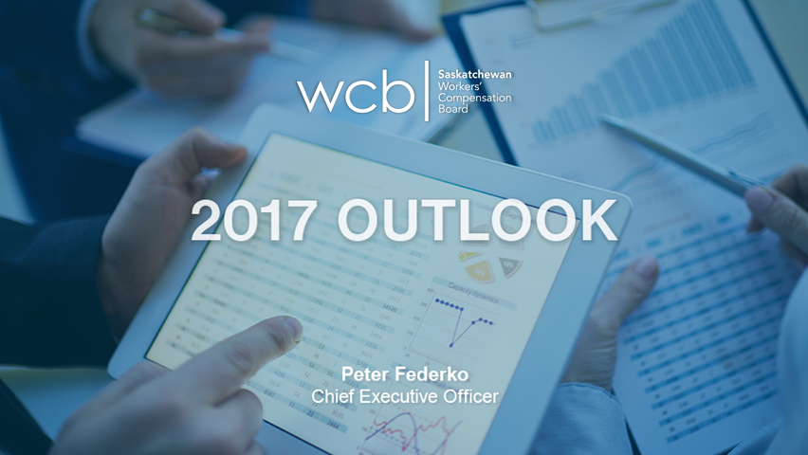

Peter Federko
I just want to provide you a bit of what we are required under legislation to provide you some information with respect to kind of what we see going forward and kind of what some of our challenges and opportunities are, what our plan is and what our forecasts are for the coming years. First I just want to talk in a little bit more detail about the approach that we take in translating the strategic plan that the board gives us into actual operational plans.

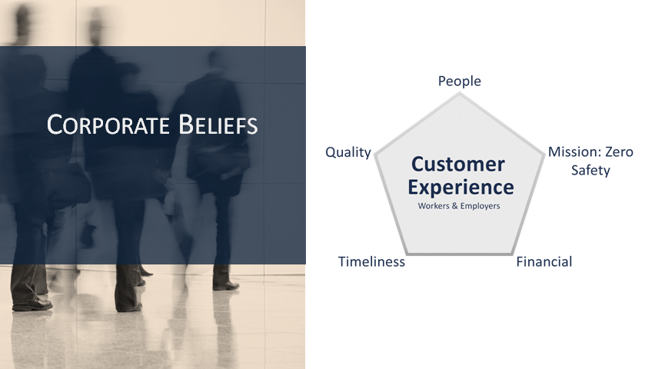

If look at our strategic plan you will see something called corporate beliefs which are in addition to the corporate values that we would have as an organization. Our corporate beliefs focus around the centre of this pentagon here the customer experience. It relates back to the Vision and Mission Statements about us providing excellence in service. In order to create some focus and alignment between the strategy and what our frontline people would actually do on a day-to-day basis we have this corporate beliefs that tie the five key things we believe are central to improving the customer experience together. The first one up at the top there is our people. We believe that engaged and healthy people are better positioned to serve our customers and so we strive to provide a healthy work environment both physically and emotionally for our workers and create engagement around continuous process improvement with our staff.

Next we have a focus on Mission: Zero. First of all our fundamental belief around Mission: Zero is that every injury is predictable and preventable, but we understand that employers rely on us and workers rely on us to assist in helping them eliminate injuries, help them achieve Mission: Zero, and we also understand that our staff ought to be entitled to the same thing, that we ought to be able to provide an injury-free environment right within the Workers’ Compensation Board. We also understand that we need to provide value for our customers but at a fair and reasonable price, so we focus on the financial aspects of this to ensure that decisions that we are making are providing the best value for money that we can. We pay attention to that. We also understand that it’s critically important that we are able to meet all of our future obligations moving forward so that benefits are never jeopardized.

Fourthly, we also understand and are attentive to our customers expecting us to provide the right service at the right time when they need it, on a timely basis. And lastly, we believe that our customers expect us to deliver defect-free services and focus on the quality of the services we provide. At the centre of this is enhancing the customer experience. We believe that workers and employers expect and deserve excellent service from the Workers’ Compensation Board. We believe that that’s why employers actually pay us. And when we talk to employers, employers are not just focussed on how well we are administering the money to which we have been entrusted, but they are also wanting to ensure that the services that they paid for, for their workers are actually being delivered to their workers on a timely cost effective and defect-free basis.
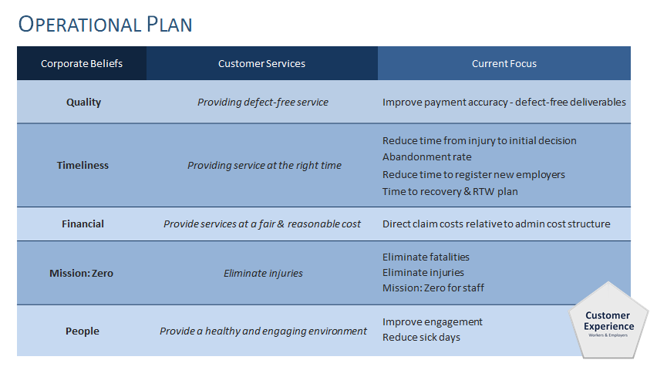

As we approach our operational plan, so when we step off the strategic plan and now plan around specific things -- I mentioned to you before about us using the balanced scorecard for purposes of reporting to the board and tracking our results toward strategy. Now we drill down to a more navigational basis. So how do we translate those corporate beliefs into actual measurements that we can provide to our staff to create that line of sight or understanding from strategy to what we are expecting on a day-to-day basis? So relative to each of those five what we call our Corporate Beliefs or our True North Metrics we have attached indicators to those. On the quality side -- again we are looking for defect-free service -- the indicator that we have chosen is we want to improve payment accuracy. We want to get the wage loss payments, we want to get our medical payments that we make accurate the first time to eliminate rework and not frustrate the heck out of our customers.

On the timeliness basis there are four things that we track and are looking at. We want to reduce the time from injury to initial decision. We want to be more timely in terms of answering the phones and so we track our abandoned rate, the number of calls or percentage of calls on a daily basis that either did not get answered, the customer hung up, or the customer had to leave a voice message because we weren’t able to get that call. We have a target. We want 5% or less of calls abandoned. Phil also mentioned the extension of phone and lock-in services over the lunch hour both for workers and employers. We are specifically tracking what’s happening over that lunch hour period compared to what’s happening over the rest of the days, and we can now do that through improvements to our phone systems, we can actually do that on kind of a half hour, hourly basis. So we also look at, “When are they taking their coffee breaks and is that creating some perhaps blips in terms of our ability to answer calls and how might we respond to that?” We want to reduce the time to register new employers. Mick talked about increasing durations and we are not real thrilled with that particular indicator and have been looking for alternate indicators in terms of program effectiveness. One of the key indicators in terms of timeliness of return to work has to do with how quickly we actually get a recovery and return to work plan on the file that we can start facilitating the partners in that particular recovery return to work plan to effectively have a safe and early return to work. We are tracking that as an indicator.

On the financial side we want to measure the relative admin costs to the direct costs or program costs that we would be incurring. On the Mission: Zero side, we want to eliminate fatalities, we want to eliminate all injuries, and we want Mission: Zero for our staff. Sadly to say that we as the WCB are not one of those employers who achieved Mission: Zero; we did have injuries last year. And of course on the people side we want to improve the engagement scores as indicated by the surveys and pulse surveys that we do looking at alternate tools that we can use and we want to reduce the number of sick days. So our belief is, corporately, that if we focus on these five corporate beliefs the customer experience at the centre of this will be achieved. And we track our progress with respect to each of those beliefs using these particular indicators, which again are reported up to the board in addition to the broader navigational metrics that we would provide to them.

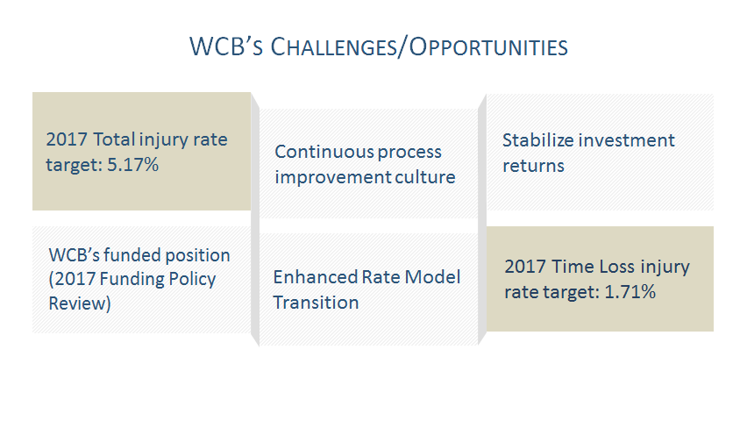

What are our challenges looking forward? Phil mentioned and showed you the significant reductions in our total and time loss injury rates since 2002 and the dramatic decrease since 2008. So as Phil said, we have seen a 62 ½% reduction in our time loss injury rate since 2002. But if we actually track from 2008 to 2016, so 2008 being the year we introduced Mission: Zero, the injury rate dropped by 49.7% in that period of time. The lion’s share of that 62% reduction, like 80% of that reduction, has been achieved since the introduction of Mission: Zero. On the total injury rate side we have seen similarly about a 54% decrease, in our total injury rate from 2002 to 2016. 88% of that reduction has been achieved since the introduction of Mission: Zero. Our challenge is continuing to drive this down towards zero and not becoming complacent. We have set a target for a total injury rate for 2017 of 5.17% and a target for our time loss injury rate at 1.71%, so this is a reduction from 5.55% down to 5.17% and a reduction on the time loss side from 1.86 down to 1.71. So continuing to be committed to the four pillars of our WorkSafe strategy, and driving those injuries down even further and closer to Mission: Zero will continue to be a challenge for us.
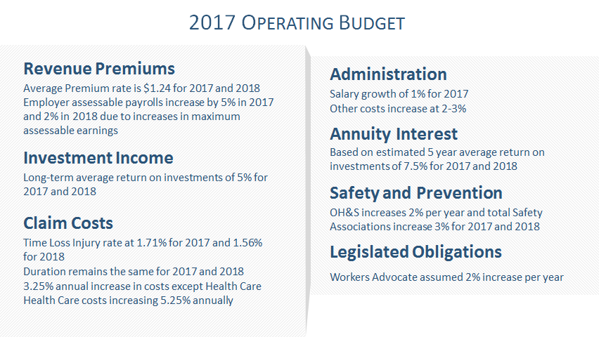

On the investment side I mentioned in my opening remarks that we had embarked on an asset optimization strategy. So looking at where we are investing or how much of our money we are investing in the various asset classes, since 2014 we have added three additional classes to our portfolio, Global, High Yield Bonds, Global Low Volatility Equities, Canadian Low Volatility Equities, the intention being to stabilize the returns so that we don’t have as much volatility in the returns that we are seeing off our investment portfolio.

Continuous process improvement, culture, developing this, staying focussed on this and committing the time and effort to it will continue to be a challenge for us for years to come. The funded position -- I mentioned, and again in my introductory comments, that we had, the board has recently approved changes to our funding policy. We floated a discussion paper in early 2017 to our customers asking them for feedback on the various elements of our funding policy, and after the feedback we received, for which we were very thankful, the board has decided that with the exception of a few things the funding policy is going to remain intact. So we will not be going to a market based and will not being including unrealized gains and losses in the determination of our funded position simply because of the volatility. Our funding range will remain at 105 to 120; however, on the surplus distribution side the board has decided to make it explicit in the policy that where we do have surplus distribution -- so that means our funded position exceeds 122% -- that that excess surplus at the board’s discretion will be issued in the year following. The current policy says over a five-year period at the board’s discretion. This says with the board discretion it will be paid in the following year. If we fall below 103% -- the current policy again says we have up to five years to replenish the fund up to 105 -- the new policy shortens it up to a three-year period. The new policy also makes it clear that if our funded position falls below 100% we will seek to replace those funds immediately. For the most part the funding policy in terms of the funding range. In addition two other things that have been decided on our balance sheet or several hundred million dollars of liability called annuity fund payable, that annuity fund is actually not being included in our funded percentage so we have not taken that into account; we have only looked at our future benefit liability for wage loss and medical. The decision was made to actually include that in the determination of our funded position to ensure that that’s being funded as well. I mean we do have an obligation to fund that to future retired workers as they turn age 65 and therefore we ought to ensure that we have sufficient funds for security or benefit purposes to fund those annuities. So that will now be included in calculating the funded position.

And the last decision that was made is we will not be -- there was suggestion made by one of our actuaries that we collapse our reserves and just roll that into the injury fund and then expand the funded range in order to make up the difference. We will not be doing that and we will be maintaining the disaster and second injury reserves as they currently are. That will come into effect for 2017. The enhanced rate model so implementing that new model. Gord also told you that the board has decided to fund the transitional costs from the old model to new model out of the injury fund, so we will be taking just over 11 million dollars out of the injury fund in order to fund the transitional costs of moving from the old model to the new model. Now that 11.3 or 11.7 million dollars is an estimate based on the difference between premium rates charged under the new model for 2017 compared to premium rates charged under the old model for 2017. So that 11.3 or 7 or whatever the number is, just under 12 million dollars, will be adjusted for whatever the 2018 premium rates are. We don’t know what those rates are yet. The new rate model is coming into effect January 1, 2018. At that point in time we will calculate 2018 premium rates under the current model, compare that to 2018 rates under the new model, and any premium rates that are going up as a result of that, that transitional cost will be funded out of the injury fund. Subsequent to 2018 premium rates will be 100% driven by the experience of the employer. There are no longer any transitional costs that will be funded, so we are just going to get it all done with if you will in one year. What that means for those employers who are receiving premium decreases as a result of that new model, you will realize that benefit immediately in 2018, not over some transition period. Still some work to do and still some challenges ahead of us in terms of improving the value to our customers, striving for excellence in service to our customers and achieving Mission: Zero.

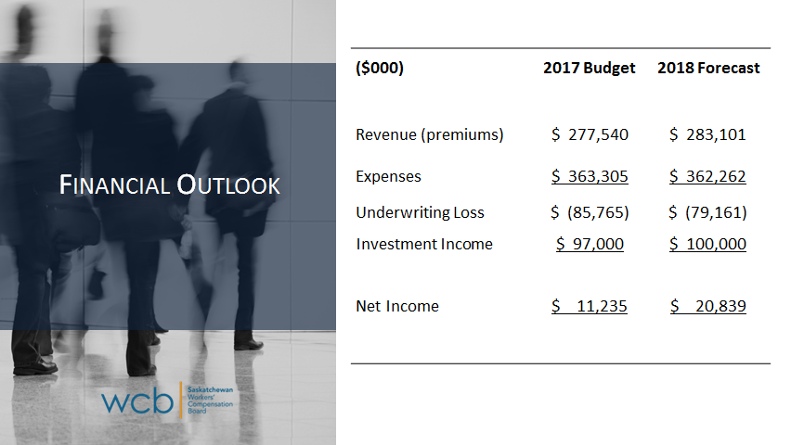

One of our other obligations is to show you our forecast for the year. We have the 2017 operating budget as well as some forecasts for 2018. Some assumptions have gone into the preparation of these budgets and forecasts. We have assumed our premium rate is going to stay at $1.24 for both 2017, for purposes of the projections. Part and parcel of that is the increase in payrolls. We budgeted a 5% increase in 2017. I’m not sure we will see that. Payrolls are flattening off a little bit as in early days of assessing. We forecasted an increase of 2% in 2018 and a large part of this, about 2% of that, is as a result of the increase in the maximum insurable, so not necessarily economic growth that we are forecasting for 2018. Investment income, we have assumed an average rate of return of 5%. For claims costs we have used our forecasts of the injury rates, so a time loss injury rate of 1.71 is our target for 2017, 1.56 for 2018. We have assumed durations will stay at the 43 days for ’17 and ’18. Our costs, with the exception of health care, we are expecting wage costs and whatnot to increase by 3.25% and health care costs, however, by 5.25%. Administration costs, our budget includes a 1% increase in our salary and benefits, other costs for inflationary purposes were assumed to increase by 2%. We have assumed an average rate of return of 7 ½% on the annuity. A safety association increase as legislative obligations, increasing roughly by 2% or the cost of inflation. When we apply that and look at 2017 and 2018 forecast we are projecting at this particular point in time, without any payroll adjustments at this particular point in time, a net income of 11.2 million dollars for 2017 and we are forecasting a net income of 20.8 million dollars for 2018. This will put us in a funded position, a forecasted funded position for 2017 and 2018 of roughly 118%. We are at 118.7 right now, we are seeing a slight decrease in that funded position because we are expecting our benefit liability to grow and offset what we are going to be adding in terms of net incomes, but basically a flattening of the funded position at least for the next two years.
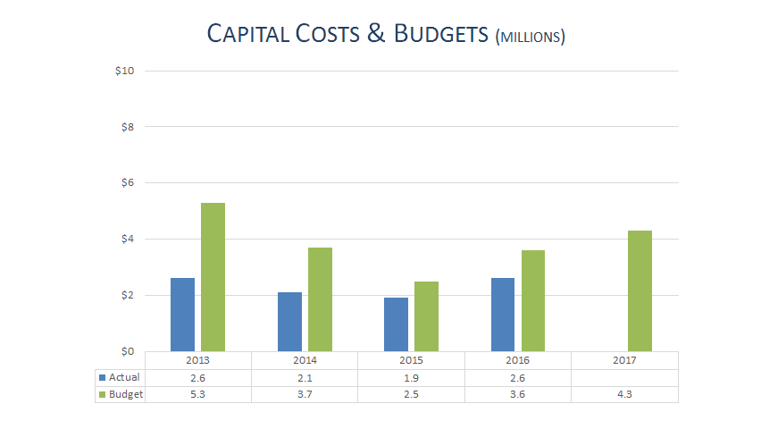

We are also required to report to you what we are expecting in terms of capital budgets. We had budgeted 3.6 million dollars for 2016. Due to delay on some projects we only spent 2.6 million. We are hoping to get those projects back on track. 4.3 million dollars is our budget for 2017 and most of that has to do with system changes. Our employer services system is no longer able to be supported and so we are looking at enhancing that as well as other enhancements to some of our other technologies.

